Minimally-invasive procedure for pelvic leak points in women

Delfrate Roberto, Bricchi Massimo, Franceschi Claude*

Objective: The objective of this study was to assess the efficacy of pelvic leak surgical disconnection in women.

Context: Pelvic leak points (PLP) may be responsible for vulvar, perineal and lower limb varicose veins, especially in women during and/or after pregnancy. The accurate anatomical and hemodynamic assessment of these points, the perineal (PP), inguinal (IP) and clitoral points (CP) and their surgical treatment under local anesthetics as defined by Claude Franceschi1-3 is a new therapeutic option.

Methods: In this open-label trial 273 pelvic leak points free of pelvic congestion syndrome were assessed. They were marked using ultrasound and selected when refluxing at Valsalva + Paraná + squeezing maneuvers, then disconnected with mini-invasive surgery under local anesthesia in a single center. Surgery consisted of selective division and non-absorbable suture of the refluxing veins and fascias at the PP, IP and CP pelvic escape points.

Results:

Ablation procedures: 273 PLP: PP (n= 170), IP (n = 100) and CP (n=3). Follow up: Period =12 to 90 months (Mean = 30.12 months). Uncontrolled PLP (n=78). Controlled PLP (n= 195) where PP (n= 123), IP (n = 72), CP (n=0). No Pelvic leak reflux redo ( n = 192). Pelvic leak reflux redo (n= 3) where PP =1,6% ( n=2) and IP =1,4% (n= 1).

Conclusions:

Despite 78 uncontrolled procedures, this study suggests that pelvic varicose embolization prior to PLP reflux ablation is not necessary and indicated only in case of uncontrolled PLP reflux or when combined with pelvic congestion syndrome. The accurate ultrasound assessment of each specific pelvic leak as well as a special surgical technique (vein division, non-absorbable suture of veins and fascias) seems to be the key for satisfactory outcomes.

Key Words: pelvic leak points (PLP), inguinal point (IP), perineal point (PP) clitoral point (CP)

**ARTICLE**

The objective of this study was to assess the efficacy of pelvic leak surgical disconnection without previous or simultaneous pelvic vein embolization in patients free of pelvic congestion syndrome. Several studies4-6 based on various assessments (clinical, ultrasound, venography) consider around 10% of pelvic leaks in women varicose where the number of multiparous are 4 times more frequent than in nulliparous7. Particularly the recurrences after stripping were related to pelvic venous reflux and evaluated as 17% but not specifically anatomically defined and not specifically treated8. Beside the obturatory and gluteal refluxes, Claude Franceschi detected three different main pelvic leak points (PLP) responsible for varicose veins of the lower limbs in mono and multiparous women1-3, using Doppler and imaging ultrasounds. These PLP are called perineal points (PP), inguinal points (IP) and clitoral points (CP) as represented in figure 1 (Fig. 1). A PP is the superficial perineal fascia hole crossed by the perineal vein that collects the posterior labial vein, then connects to the internal pudendal vein. The perineal vein drains the skin of the perineum, then receives the posterior labial veins and passes through the superficial aponeurosis of the perineum (fascia perinalis) by way of an orifice that we call the perineal point (PP)9-11. After crossing the PP, the vein ascends with bulbar and cavernous veins to the pudenal vein in the Alcock’s canal. In case of leakage, reflux follows the same pathway in the opposite direction. Reflux can not only cause dilatation of the labial and perineal veins but also extend to the ipsilateral saphenous network through either perineal-to-labial and perineal-to-external pudendal vein anastomoses or through any other incompetent vein in between. It can also feed a contralateral varicosity through labiolabial and perineoperineal anastomoses. Reflux in the medial pudendal vein is itself fed either actively or potentially by any constitutionally incontinent ipsilateral and contralateral upstream genital, visceral iliac, and ovarian vein and by the inferior vena cava. An IP is the superficial inguinal annulus crossed by the mons veneris veins that connects to the uterine round ligament vein. Reflux of the round ligament vein of the uterus can feed vulvar (labial) and perineal varicose veins and lower extremity varicose veins via residual branches of the Nuck’s canal that reflux directly or indirectly to the subcutaneous abdominal, external pudendal, superficial dorsal of the clitoris, and labial veins, then possibly toward varices in the saphenous network. Once again, reflux in the round ligament vein is itself fed either actively or potentially by any constitutionally incontinent ipsilateral and contralateral upstream genital, visceral, iliac, or ovarian vein and by the inferior vena cava. A CP is the anastomotic plexus between the bulbar vein and superficial dorsal clitoris that connects to the medial pudendal vein**12**. Reflux can feed ipsilateral or contralateral perinal and anterior labial veins and or the lateral pudendal then the GSV. As the PLP reflux is usually fed by hypogastric tributaries and/or ovarian incompetent veins, and the PLP reflux occurs as a result of recurrence after conventional stripping, some authors suggest embolization of these veins as a first step treatment of peripheral varicose veins of the lower limbs13-14. In this study, the first step in treatment was surgical ablation of the PLP reflux in patients free of pelvic congestion. Pelvic vein embolization as the first step was indicated only in cases of pelvic congestion syndrome. PLP represent the escape point of the shunts type IV according to the Teupitz CHIVA classification15.

**METHODS**

**Study Design**

This study was an open-label trial. It consisted of assessing the long term persistence of the surgical ablation at the PLP of the pelvic venous reflux in uniparous or multiparous women free of symptomatic pelvic congestion syndrome (no chronic pelvic pain), partly or totally responsible for lower limbs varicose veins, in absence of prior or secondary pelvic veins embolization and regardless of the degree and configuration of the varicosities. The efficacy of the intervention was measured by ultrasounds in a mean follow up period = 30.12 months. Clinical data allow diagnosis of vulvar and perineal varices but cannot determine the leak point, since leakage from I, P or C points lead to the same clinical manifestations. A full color duplex scan allows precise identification of I, P and C points. The specific criteria of reflux at the PLP was a Valsalva descending flow provoked by having the women blow into a blocked straw while standing. Conversely, the diastolic flow at the descending tributaries of the Great Saphenous Veins (GSV) arch evoked by calf squeezing or Paranà maneuver is not specific and may be present in the absence of refluxing PLP, so it is a source of false positives. Continuous reflux at rest (without any dynamic maneuver) may be due to a collateral compensatory draining flow caused by a downstream obstacle and thus prohibits any disconnection. It was completed by an exhaustive ECD in order to achieve a complete hemodynamic mapping of the venous insufficiency. With the patient in a standing position, IP can be located approximately 1 to 3 cm above the femoral vein and just medially to the epigastric veins and CP medially to the SFJ towards the clitoris. The reflux is seen outwards throughout the inguinal canal (Photo1a-1b). PP is generally located at the junction of the posterior fourth and anterior three-fourths of the labia majora . It can be detected if the patient is in a standing position with her foot resting on a platform 20 cm high or in a lithotomy position for a transperineal ultrasound (not intravaginal because the probe imaging would be too deep compared to the superficial PP). The reflux activated by Valsalva maneuver induces backflow from the Alcock’s canal to the perineal and labial veins (Photo 2). The Alcock’s canal is located medially to and just above the ischiopubic branch. The study was conducted by the same surgical team who performed ultrasound diagnosis, mapping and pre-operatory marking as well as the procedures.

All patients with congenital venous disease, VVs secondary to prior deep vein thrombosis, , sclerotherapy, associated systemic pathologies, those who refused surgical treatment, who could not participate in long-term follow-up or had given birth less than 9 months previously were excluded from the study. A written informed consent was provided to the patients. The diagnosis was assessed with Echo-Color-Doppler (ECD) by the surgeons thanks to a 10-18 MHz linear probe. The PRF was set between 0.75 and 1 KHz, capable of detecting even low-speed reflux from 0.05 to 0.10 m/s.

**Interventions**

The patients were ambulatory. The same surgeon performed the marking and inter­vention. The anesthesia was local: less than 3 ml of a mixture of lidocaine (2%) and ropivacaine (7.5 mg/dl). Incision according to skin marking: from 10 to 14 mm (Photo 3-4). Effective treatment of lower extremity superficial venous reflux of pelvic origin can only be achieved by ligation of the leak points in the same way as is necessary to ligate a refluxing perforating vein or junction. Proximal or distal ligation without ligation at PP and/or IP will be followed by recurrence due to collateral flow (Fig. [2](http://link.springer.com/article/10.1007/s10016-004-0180-9/fulltext.html#Fig2)). The perineal and inguinal leak points (points *P* and *I*) act as perforating veins. Remote disconnection (*B, C*) invariably fails either immediately or secondarily because of the presence of many branches and anastomoses (Fig. 3). Perineal and genito-crural nerves were preserved respectively at the PP and IP. Division and stump ligation of the refluxing vein with non-absorbable braided coated suture and additional polypropylene 6 zero monofilament transfixed suture for the PP, and 4 zero for the IP. Furthermore, the stump of round ligament was positioned inside the inguinal canal, sutured with a polypropylene stitch to the fascia of the oblique external muscle. The fascia hole of the posterior labial vein was also closed with a No six zero polypropylene suture. This procedure was associated at the same time or later with additional shunt disconnections and gravitational hydrostatic pressure segmentation tailored to each specific hemodynamic configuration according to the CHIVA strategy16-19. A washing with a rifampicin solution had been done in every surgical procedure, without any systemic antibiotic therapy. All patients wore elastic stockings for 4 weeks, and took Enoxaparin 4000 IU. for 1 to 2 weeks. We recommended the use of paracetamol (1g tablet) if they were having pain. No deep vein thrombosis, pulmonary thromboembolism, or death occurred and considering possible surgical complications (bruises, subcuta­neous inguinal or perineal hemorrhage, saphenous nerve neuralgia, wound infection and superficial phlebitis), there was only one inguinal bleeding (immediate surgical exploration of the inguinal canal and hemostasis thanks to a vessel legation). All patients were assessed 8 days after surgery. The efficacy of the intervention (the primary end point) was evaluated checking the Doppler response provoked by the Valsalva maneuver at the treated PLP. Reflux was considered a failure, no reflux was considered a success.

**RESULTS**

255 consecutive PLP participated in the study from 2003 to February 2015 among 4209 CHIVA procedures for lower limbs varicose veins in females Diagnosis, treatment and follow up where performed by 2 surgeons. The efficacy of the intervention (the primary end point) was evaluated checking the Doppler response provoked by the Valsalva maneuver at the treated PLP. Reflux was considered a failure, no reflux was considered a success. The follow-up period was from at least 12 to 90 months (Mean = 30.12 months). Ablation procedures: 255 PLP: PP (n= 170), IP (n = 82) and CP (n=3). Uncontrolled PLP (n= 60). Controlled PLP (n= 195) where PP (n= 123), IP (n = 72), CP ( n=0). No Pelvic leak reflux redo (n = 192). Pelvic leak reflux redo (n= 3) where PP =1.6% (n=2) and IP =1.2 % (n= 1). Only in one patient a redo surgery was done (recurrent and symptomatic PP reflux).

**DISCUSSION**

Despite 60 uncontrolled procedures, this study suggests that pelvic varicose embolization prior PLP reflux ablation is not necessary and indicated only in case of resistant PLP reflux or when PLP is associated with symptomatic pelvic congestion syndrome. On the other hand, prior pelvic vein embolization leaves behind a PLP reflux, even if reduced, which needs complementary superficial treatment. Sclerosing agents and foam are also used to treat the PLP by injecting the extra pelvic veins. No long term study has been published so far. This study doesn’t report the additional CHIVA disconnections nor their specific outcomes because they don’t determine the persistence of the PLP treatment. The low rate of failures may be due to the surgical technique: veins division-ligation and fascia/superficial inguinal channel suture with no absorbable monofilament suture, which is supposed to avoid both collateral reflux and neoangiogenesis (inflammatory reaction to absorbable suture), as well as the accurate ultrasound detection of the leaking points that allows for a very minimally invasive operation (Fig 2).

**CONCLUSION**

This study suggests that pelvic varicose embolization prior to PLP reflux ablation is not necessary. The embolization could be indicated only in case of resistant PLP reflux or symptomatic pelvic congestion syndrome. The accurate ultrasound assessment of each specific pelvic leak as well as a special minimally invasive surgical technique (ambulatory patient, local anesthesia, non-absorbable suture of vein stumps and fascias, low surgical risk and low percentage of complications) seems to be the key for satisfactory outcomes.

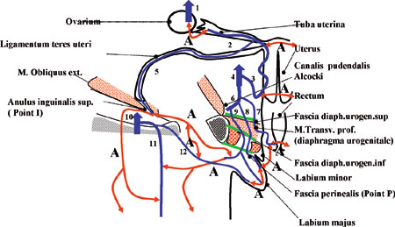

Fig. 1. Frontal view of the pelvis passing through the perineal and inguinal leak points (points *P* and *I*). Note the number of anastomoses (*A*). *1*, vena ovarica (ovarian vein); *2*, tuba uteri vena (fallopian tube vein); *3*, vena uterine (uterine vein); *4*, vena iliaca interna (internal iliac vein); *5*, ligamentum teres uteri vena (round ligament vein of the uterus); *6*, vena pudenda interna (internal pudendal vein); *7*, vena rectalis inferior (inferior rectal vein); *8*, vena pudenda interna rama (internal pudendal branch vein); *9*, vena perinea (perineal vein); *10*, vena femoralis (femoral vein); *11*, vena saphena magna (greater saphenous vein); *12*, vena pudenda externa (external pudendal vein).

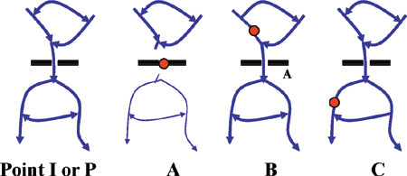

Fig. 2. Ligation of leak points. The perineal and inguinal leak points (points *P* and *I*) act as perforating veins. Remote disconnection (*B, C*) invariably fails either immediately or secondarily because of the presence of many branches and anastomoses.

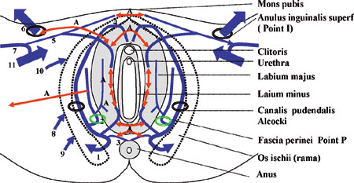

Fig. 3 Perineal view showing the perineal and inguinal leak points (points *P* and *I*). Note the number of anastomoses (*A*). *1*, vena pudenda interna (internal pudendal vein); *2*, vena perinea (perineal vein); *3*, vena rectalis inferior (inferior rectal vein); *4*, vena bulbi vestibuli et clitoridi (vein of bulb of vestibule and clitoris); *5*, vena pudenda externa (external pudendal vein); *6*, ligamentum teres uteri vena (round ligament vein of the uterus); *7*, vena saphena magna (great saphenous vein); *8*, vena glutea (gluteal vein); *9*, vena ischiatica (sciatic vein); *10*, vena obturatoria (obturator vein); *11*, vena femoralis (femoral vein).

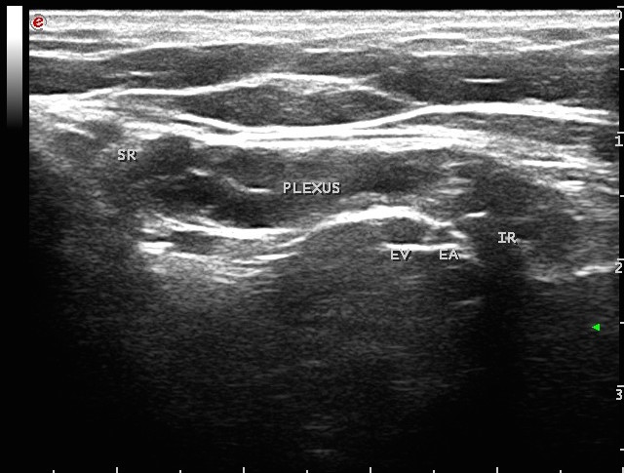

Photo1a: the venous plexus of the round ligament in the inguinal canal, its relationship with the epigastric vessels (E. Vein and E .Artery), the internal ring (IR), the subcutaneous ring (SR) through which a pelvic reflux is transmitted during Valsalva to the lower limbs. The external oblique muscle fascia is the hyperechoic line above the plexus, while the hyperechoic line corresponding to the trasversalis fascia is clearly visible below it.

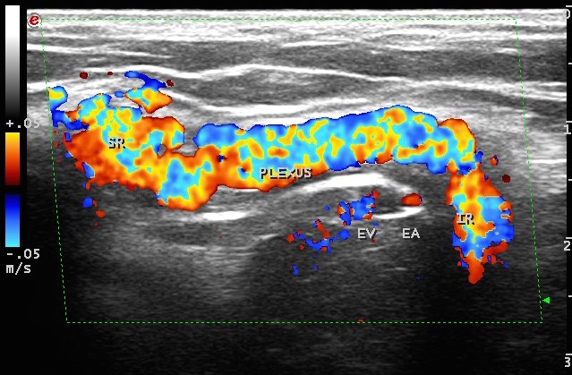

Photo 1b: Valsalva maneuver. Clearly detectable reflux from the deep pelvic plexuses towards the surface through the inguinal canal and its superficial ring

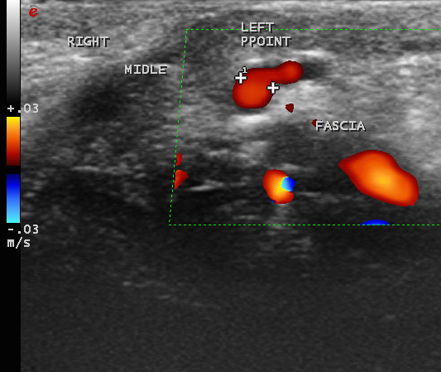

Photo 2: Valsalva reflux from the Left Perineal Point (posterior labial vein). The vulvar tissue is the black dishomogeneous part in the lower half of the picture

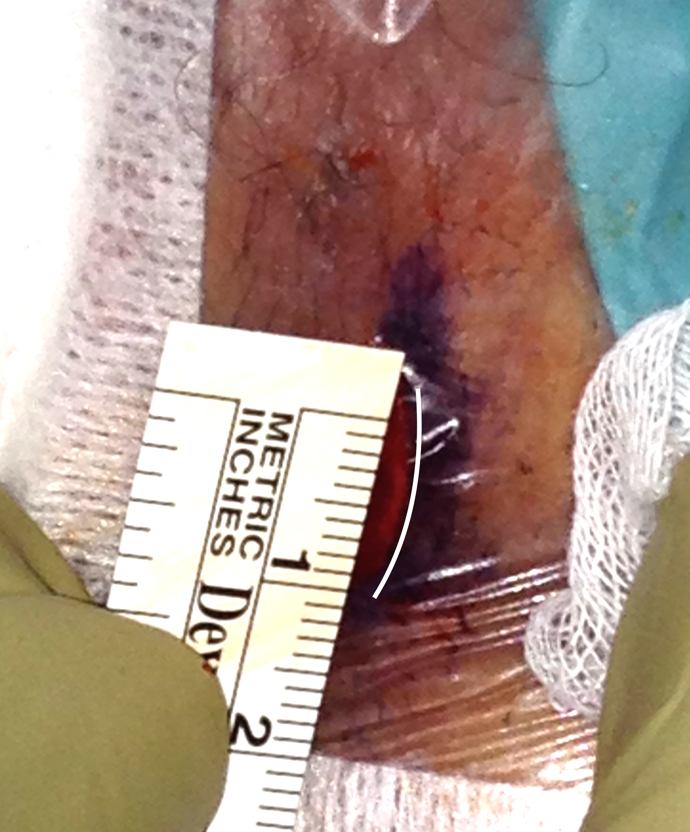

Photo 3: minimally invasive surgical access to the fascia hole of the posterior labial vein

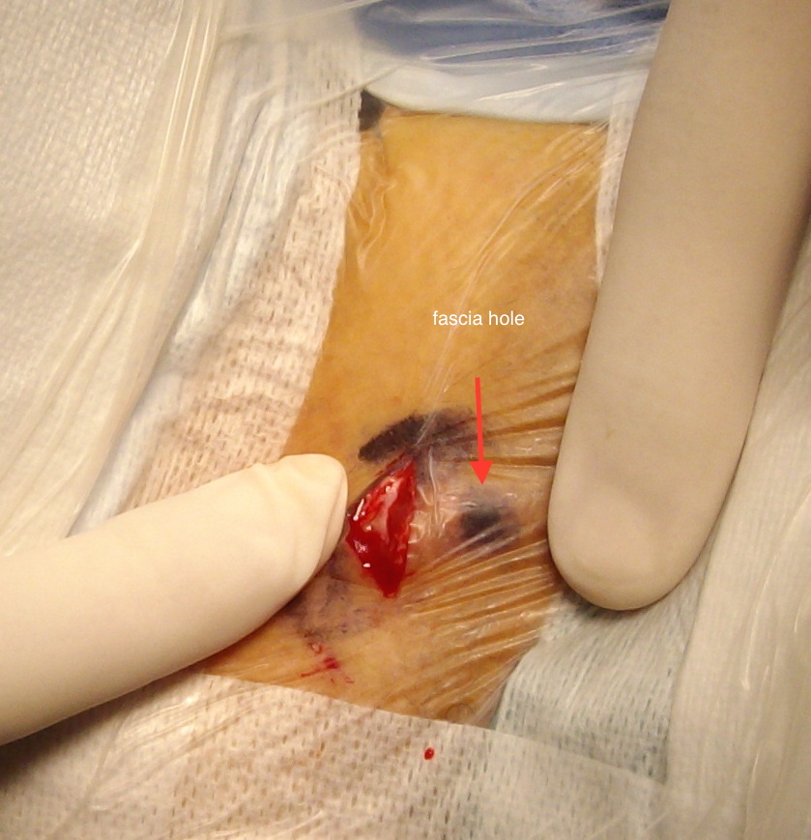

Photo 4: comparison between the skin incision and the skin mark of the fascia hole of the posterior labial vein

Bibliography

1 C Franceschi, A. Bahnini. Points de fuite pelviens viscéraux et varices des membres inférieurs *Phlébologie* 2004; 57: 37-42

2C Franceschi, A. Bahnini. Treatment of lower extremity venous insufficiency due to pelvic leak points in women *Ann Vasc Surg* 2005; 19: 284-288

3Franceschi C. Anatomie fonctionnelle et diagnostic des points de fuite bulboclitoridiens chez la femme (point C). *J Mal Vasc*. 2008;33:42.

4 Jiang P, Van RijAM, Christie RA, Hill GB, Thomson IA Non-saphenofemoral Venous Reflux in the Groin in Patients with Varicose Veins. *Eur J Vasc Endovasc Surg* 2001; 21: 550-557

5Barros FS, Perez JMG, Zandonade E, Salles-Cunha SX, Monedero JL, Hilel ABS, et al. Evaluation of pelvic varicose veins using color Doppler ultrasound: comparison of results obtained with ultrasound of the lower limbs, transvaginal ultrasound, and phlebography. J Vasc Bras 2010;9:15–23

6 García-Gimeno M, Rodríguez-Camarero S, Tagarro-Villalba S, Ramalle-Gomara E, González-González E, González Arranz MA, López García D, Vaquero Puerta C. Duplex mapping of 2036 primary varicose veins . J Vasc Surg 2009; 49: 681-689

7 Labropoulos N, Tiongson J, Pryor P, et al . Nonsaphenous superficial vein reflux. J Vasc Surg 2001; 34: 872-877.

8 Perrin N, Labropoulos N , Leon L. Presentation of the patient with recurrent varices after surgery (REVAS) J Vasc Surg 2006; 43: 327-334

9 Hafferl Anton. Lehrbuch der topographischen anatomie. Springer-Verlag Berlin,Heidelberg,New York 1969

10 Sala L, Bruni C. Trattato di anatomia umana. Ed. Vallardi F. Milano 1932, vol 4

11 Fusari R, Bruni AC. Trattato di anatomia umana topografica. Ed. UTET, Torino, 1936

12Pernkopf E. Atlas of Topographical and Applied Human Anatomy.Vol.II; 222-223

13 Leal Monedero J, Zubicoa Ezpeleta S, Castro Castro, Calderon Ortiz JM, Sellers Fernandez G. Embolization treatment of recurrent varices of pelvic origin. Phlebology, 2006; 21: 3–11

14 Greiner M. Varices des membres inférieurs d’origine pelvienne : traitement et résultats à long terme J Mal Vasc 2006; 31: C2 26.

15 Criado E, Juan J, Fontcuberta J, Escribano MJ. Haemodynamic surgery for varicose veins: rationale, and anatomic and haemodynamic basis. Phlebology 2003; 18:158-166

16Franceschi C. Theorie et practique de la Cure Conservatrice et Hemodynamique de l'Insuffisance Veineuse en Ambulatroire. Precy-sous-thil, France: Edition de l'Armançon; 1988

17Franceschi C, Zamboni P. Principles of venous haemodynamics. Nova Science Publishers. New York. 2010

18 Franceschi C and al : [CHIVA: hemodynamic concept, strategy and results](http://www.minervamedica.it/en/journals/international-angiology/article.php?cod=R34Y2016N01A0008). [International Angiology 2016 February;35(1):8-30](http://www.minervamedica.it/en/journals/international-angiology/article.php?cod=R34Y2016N01A0008)

19 Delfrate R. A new diagnostic approach to varicose veins: haemodynamic evaluation and treatment. Lorenadioni Publisher 2014