5. Hemodynamic changes in chronic venous disease

Write: Andre Van Rij & Mark Meissner
Assist to write: Byung Boong Lee, Claudio Allegra, Claude Franceschi, Marianne De Maeseneer, Ken Myers
Review: Robert Kistner
Coordinate: Mark Meissner
a. Hemodynamic factors and wall remodeling
b. Hemodynamic changes with disease (Obstruction, reflux or both) in superficial
veins, perforating veins, deep veins, pelvic veins, venous malformations and venous
wall (poor compliance due to recanalization) and microcirculation. (Claude
Franceschi)
c. Effect of hemodynamic changes on the microcirculation and inflammation.
Starling’s law and pathophysiology of edema of venous origin (Claudio Allegra)
d. Hemodynamic changes associated with congenital vascular malformations (BB
Lee & J. Laredo)
Hemodynamic changes in chronic venous disease : C. FRANCESCHI’s contribution
Chronic venous insufficiency and its clinical signs relate to any permanent or transitory excess of TMP whatever its cause that must be assessed by instrumental means. Most of the time, the cause is the incapacity of the valvulo-muscular pumps to correct the negative effects of standing. The other causes are less frequent (e.g., chronic venous occlusion, arterio-venous fistula, and congenital venous hypoplasia).
Understanding and setting the pathophysiologic hemodynamics are based on both technical means of investigation and theoretical patterns. More than a century ago, Trendelenburg demonstrated the impaired fractionation of the blood column achieving a delayed varicose GSV swelling when passing from lying to standing provided that he kept pressed the arch with his finger [1 ] . His assistant Perthes proposed a test that suggested the hemodynamic effects of the muscular pump. The test consisted in placing a tourniquet at the thigh root of these patients and making them walk. The varicose GSV collapsed unless the deep veins were impaired (Fig 1). Then were performed the invasive pressure measurements [2,3] , venography, [4 ], plethysmography [5,6 ] and at last Duplex Ultrasounds ( DUS) two decades ago [8,9,10,11], that for the first time made possible in live and at the same time viewing the veins ( wall, valves and blood) and measuring the flow, in any posture and movement. Supplementing the invasive data with which they are in accordance, the latter provided invaluable new hemodynamic information that allowed new concepts and models [12,13,14,15,16] able to improve dramatically both diagnosis and treatment today validated by studies and long term RCTs. [17,18,19,20]
The difference between acute and chronic venous disease is essentially clinical while the hemodynamic concepts for the assessment techniques are identical.
Before describing the hemodynamic changes in venous insufficiency, some concepts and definitions need to be precised.
Transmural Pressure (TMP) is the key parameter of venous hemodynamics because it is the gradient pressure (GP) essential for the venous function, i.e the tissue drainage in accordance with the Starling law and the venous bed volume/calibre according to the Laplace law and the compliance ( wall ability to stretch)). TMP is the difference between intravenous lateral pressure (IVLP) and extravenous pressure (EVP). Physiologically, the venous system regulates the IVLP in order to maintain a favourable TMP. The IVLP is the sum of three pressures. Fig 2 The first one is the Residual Pressure (RP) provided to the venous end of the microcirculation. It results from the arterial flow pressure reduced by the microcirculation resistance that varies according to the microvascular calibre (vasomotion). The second one is the Gravitational Hydrostatic Pressure (GHP) that depends on the overlying blood column height, thus on the body posture. The third one is the Muscular Pump Pressure (MPP) resulting from the muscular contraction around the veins. So, the hemodynamic changes can relate to one or a mix of TMP regulation impairment regarding the RP, the GHP and the MPP. According to these elements, hemodynamic venous insufficiency ,e.g. the hemodynamic aspect of the venous insufficiency , could be defined as the inability of the venous system (pumps and conduits) to maintain a correct TMP whatever the posture and the muscular activity.
The venous pumps are the mechanisms that move the venous blood. Two of them are permanently active: cardiac pump (heart) and respiratory pump Rp (abdomino-thoraco-diaphragmatic). The third one is the muscular pump (MP) active only during the movements, particularly during ambulation.
The venous conduits are characterized according to their calibre and compliance (active/passive).
The venous valves are orientated according to the cardiopetal flow direction. They participate in three functions. Firstly, as they stop any reverse flow, the valves guarantee the cardiopetal hierarchical direction of the venous flow ( Fig 3) [13,14,21] from the saphenous tributaries (N3) to the saphenous trunks (N2) then to the deep veins (N1) through Saphenous-Femoral Junction (SFJ), Saphenous-Popliteal Junction (SPJ) and perforators or directly from N3 to N1and superficial network through perforators [8 CF, caggiatti). Secondly, they are necessary to the efficient function of the venous pumps. Thirdly, thanks to their systole/diastole alternate closure, they prevent the excessive TMP in upright position by fractionating the GHP column during ambulation ( Dynamic Hydrostatic Pressure Fractioning DHPF) (Fig 4) [22, 23]. The conditions for flow inversion are double. The first one is a necessary inversion of the pressure gradient. The second one is the waterproof valve closure after a very short physiologic reflux. So, a valve incompetence and reflux are not synonyms, because incompetence is responsible for reflux only when the pressure gradient is inverted. The venous reflux is usually defined as an opposite flow to the valves direction (retrograde), independently of its hierarchical draining relevance, its blood composition, the PG inversion conditions, its origin and its destination. Therefore, reflux is just an “unspecific sign” that must be related to the hemodynamic configuration where it occurs. For instance, a retrograde flow (reflux) relates to different pathologic patterns according to its location, the conditions of its occurrence (at rest, during Valsalva manoeuver, systole (contraction) or diastole (relaxation) of the muscular pump, superficial flow fed or not by deep venous network, etc..). On another hand, the degree of reflux is proportional to the inverted pressure gradient and to the degree of valve incompetence. For this reason, this degree can vary according to the PG achieved by the posture changes, the cardiac, respiratory and muscular pumps (spontaneous or triggered by various stress tests) so that the quantitative tests are difficult to standardize.

- RP excess : Venous obstruction, low microcirculation resistance, arterio-venous shunts.
- Venous Obstruction:
The hemodynamic effect of the venous obstruction depends on the resistance opposed to the outflow. The resistance obeys to the Poiseuille’s law , i.e predominantly proportional to the calibre reduction of the downstream veins ( see above chap 2). Phlegmasia cerulea and venous claudication represent two extreme cases of the venous obstruction. The first one is static and the total occlusion of the deep veins of the lower limbs by extended thrombosis stops completely the venous flow and consequently the arterial flow and shows a typical combination of swelling and ischemia. The second one is dynamic and is caused by a painful increase of the venous pressure due to the resistance to the systolic flow ejected by the muscular pump during ambulation. (walking, running etc…) Fig 5. In most cases , the venous obstruction is less important and results in variable RP excess clinically expressed by a variable degree of swelling. Depending not on the GHP, the swelling is permanent ( not reduced by the lying position) but can decreases with time when the resistance lessens thanks to an obstruction reduction and / or collateral veins opening. Indeed, the high pressure forces and overloads the collateral tributaries ( called varices when clinically visible) which play the role of a natural by-pass ( also called Vicarious Open Shunts (VOS)) that can reduce the pressure down to normal .The OVS flow is permanent and increased by the MP systole. Its direction can be antegrade, for example: GSV flow by-passing a popliteal vein obstruction, or retrograde (reflux), for example: retrograde epigastric flow by-passing a cava vein obstruction. These varicose VOS grow gradually and can be visible only months and years later (post phlebitis disease, varicose veins recurrence). Fig 6 The venous obstruction can be anatomically elicited by imaging ( venography, MRI, Duplex US) and its hemodynamic incidence can be assessed by invasive pressure measurement and as well as by non-invasive methods ( plethysmography and Doppler).
- Cardiac pump defect
Normally, the cardiac pump maintains such a low proximal ( central) pressure that the distal RP remains low. Right ventricle failure reduces the venous pressure gradient and increases the distal venous RP pressure responsible for distal venous dilation and edema. The cardiac pump can also induce a systolic reflux into the proximal veins in case of severe tricuspid incompetence.
- Respiratory pump defect
Normally, the respiratory pump induces a cardiopetal flow in the lower limbs. Blocked expiration by coughing, defecating, weight-bearing reverses the pressure gradient such that the flow would reverse too if not contained by the distal competent valves. Obviously, the reflux will occur in proportion to the incompetence of those valves. The Valsalva maneuver reproduces that blocked expiration and permits to detect incompetent valves when it produces a reflux. The reflux is submitted to particular hemodynamic configurations. It is always positive in the deep incompetent veins but, in the incompetent superficial veins, it occurs only if the communication (perforators, SFJ and SPJ) between deep (N1) and superficial veins (N2, N3) ) is incompetent and realizes an escape point (see below). Therefore the Valsalva test makes the distinction between superficial reflux made only of superficial flow (negative Valsalva) and reflux overload by deep venous blood (positive Valsalva).

- Low microcirculation resistance
The superficial venous network plays the role of a radiator that expels calories outside of the body in order to reduce the excess of the central temperature, particularly in hot environment.For that, the superficial venous flow/RP increases in proportion to the decrease of the microcirculation resistance ( vasodilation). In excessively hot environments , this regulation can lead to permanent excessive TMP responsible for dilation of superficial veins and drainage impairment.
- Arterio-venous shunts (AVS)
AVS can be congenital, secondary or therapeutic (renal dialysis ). They increase the RP in proportion to their grade and can be responsible for varicose veins and drainage impairment clinical symptoms.

- Muscular Pump Pressure excess( MPP)
Extreme exercise like with Sportsman, increases at the same time the RP because of the low microvascular resistances ( vasodilation) and the MPP. It can result in dilation of superficial veins up to varicosis. This could be a reason for the disappointing outcomes of these varicose-like vein ablation (see above venous obstruction). In case of obstruction, both low microvascular resistances ( vasodilation) and the MPP can be responsible for claudication (Fig 5).

- Gravitational Hydrostatic Pressure Fractioning (GHPF) defect
- Valve competence and Still Posture :
In absence of movement valves remain open. So, still long upright and sitting stances are responsible for TMP excess because of the muscular pump inactivity (open valves) , i.e absence of dynamic fractioning of the high GHP column elevated by these postures. This is the reason why these still postures can be responsible for clinical symptoms of hampered drainage despite an underlying “normal” venous system. For this same reason and because of the high venous compliance, the venous volume of the lower limbs increases progressively, playing the role of an intravenous hemorrhage that can lead to a transitory heart failure and a consecutive fainting.
- Valve incompetence, still Posture and ambulation.
The muscular pump (MP) correct function needs a good muscular condition and valve competence. As seen before, the still upright position can’t last for long without pathologic effects because of the GHPF defect. The MP action alone can insure a proper distal TMP thanks to the alternate valve closure. The invasive pressure measurement at the ankle shows no difference between normal and incompetent patients in various positions (standing still, lying down and elevated extremities) while the difference is dramatic during walking-like manoeuvers (decrease down to 30 mmHg in normal when it remains high proportionally to the incompetence in the patient (Fig 7). The valve incompetence impairs the distal GHPF in proportion to the valve leak but also to the level of the incompetent valve (Fig 8) Resek [3]. Has shown that the iliac and femoral valve incompetence doesn’t change the correct fractionating below the knee provided the popliteal valve is competent, which is coherent with the DHPF pattern. Despite a correct valve closure at both ends of the MP, the DHPF can be impaired if any incompetent vein collateral to the pump maintains a continuous (not fractioned) column of blood. It is the case of most GSV and SSV incompetence (Fig 9) but also of some of deep venous incompetence ( e.g when only one of a double femoro-popliteal vein is incompetent). For all these reasons, the reflux induced by the MP can be assessed properly only in the upright position while activating (Paraná maneuver and others) or simulating (squeezing) the muscular contraction (systole) and relaxation (diastole). A MP diastolic reflux is physiological and its time is inversely proportional to the inverted GP and proportional to the leaflets inertia (rigidity) ( when the wind slams a door , some air crosses it necessarily during the closure and the time of closure depends on the strength of the wind and the lubrication of the hinges ) [24].
- Muscular pump and valve incompetence
The valve incompetence produces different patterns of abnormal flows and pressures according to their topographic relation with the MP. In normal mode, during the MP activation, the hierarchal physiologic drainage N3-N2-N1 or N3-N1 is achieved by the correct location of competent valves that prevent refluxes and back pressure strikes triggered by the systole and/or the diastole. Normally most of the energy provided by the MP is spent for draining the blood and delivering the blood to the heart. Valve incompetence can divert this energy in an unfavorable way for the drainage, even if the MP works properly as for example in case of superficial venous incompetence. This pattern accounts for the various hemodynamic configuration and their pathological impact according to the incompetent valves location (e.g. shunts classification [12,13,14,23])

- Muscular Pump systole and valve incompetence : open shunts
The MP systole propels the distal venous blood towards the heart thanks to the proximal valve opening and distal valves closure. In case of incompetence of the distal valves of the MP, part of the systolic energy/pressure will be abnormally delivered back. The systolic flow will produce a reflux through any downstream perforator according to its incompetence, angulation with the vein and the respective resistance/pressure of the deep and superficial veins. The tighter the angle and respectively lowness of the superficial resistances, the bigger systolic reflux will be. This reflux is welcome in case of downstream deep venous obstruction because it provides a by-pass around the obstacle to the drainage. This occurs also in case of SPJ systolic reflux that ascends through the Giacomini vein and re-enters into the deep veins through the proximal GSV end and/or a proximal re-entry perforator. Sometimes this configuration could be explained by a femoral congenitally smaller than the opposite side one (reference of KTS, BB Lee) and accounts for the recurrence of SSV ablation. On the other hand, valve incompetence can be secondary to deep venous chronic thrombosis as elicited by the frequent SFJ systolic reflux secondary to the high femoral pressure upstream an iliac vein block ( Spontaneous Palma operation) [12,13,14,23]. (Fig 10)
- Muscular Pump diastole and valve incompetence : diastolic reflux

The diastolic venous reflux can affect part or all of the deep veins of the lower limbs and its hemodynamic relevance can be related to the location and to the incompetence degree of their valves.
Several measurements of the reflux are proposed in literature [24, 25] taking account of the reflux time and the reflux amount. Another method can be suggested, taking account of the level , location and degree of incompetence. The latter is based on the following rational.
The reflux can be “total” when all of the valves above the measured reflux are totally absent or incompetent, so that the time and peak of the reflux are almost symmetrical to the systolic outflow. It can be “partial” when valves are not totally incompetent and the reflux is slowed down through the valve by a small leak point so that the reflux time is longer and the velocity lower than the systolic outflow. It can be “segmental” when the valves overlying the incompetent one store part of the systolic outflow so that only a small part of the systolic outflow refluxes and the reflux time is almost equal to the systolic but its peak is lower[25] . Fig 11

- Muscular pump and closed shunts [12,13,14,23].
In addition to the lack of HPDF, valve incompetence can be responsible for varicose veins and drainage impairment because of inappropriate distribution of the MP energy (flow and pressure). It is the case when an incompetent vein (deep or superficial) collateral to the MP connects to the two ends, distal (a) and proximal (b) of a competent MP. This incompetent collateral cannot block the reverse flow triggered by the diastolic inversion of the PG. It therefore plays the role of a shunt that during the diastole, part of the blood expelled through (b) during the systole returns back to (a). So, this shunt working in closed circuit, and can be called Closed Shunt (CS).
The reflux can last longer with a higher velocity when the amount of diastolic reverse flow is greater than the systolic outflow because overloaded through an incompetent connection by a collateral/tributary flow ( e.g. in case of Closed shunt). A closed shunt (CS) occurs when one of two tributaries/collaterals is incompetent while the other one is competent. During the systolic phase the flow is propelled upward into both collaterals and, during the diastole, the incompetent vein receives back its systolic flow plus the flow of its competent collateral/tributary. The refluxing collateral can be a deep or a superficial vein. We can call them deep CS in the first case and superficial in the second one. These closed shunts are activated by the diastole. Indeed, during the diastole an incompetent connection proximal to the MP ( e.g saphenofemoral junction) makes the deep blood reflux throughout an incompetent superficial vein ( e.g GSV) down to a perforator ( below knee re-entry) distal to the MP and then into the deep veins. This closed circuit is activated by each systole/diastole of the MP. The hemodynamic effect of this configuration is not only a DFHP impairment but also an additional pressure/flow due to the CS diastole that restitutes back part of the CS systolic pressure/flow. Different patterns of superficial CS can be described according to its pathway. Shunt 1 when the reflux fed by at SF leak runs inside a segment of a saphenous trunk (N2) then into a re-entry perforator, shunt 3 when it runs into a segment a saphenous trunk then into a tributary (N3) without any intermediate re-entry perforator etc…(Fig 12) . A deep CS occurs when for instance one of the double femoral veins is incompetent. Such data are necessary for an appropriate hemodynamic therapeutic.

- Muscular pump and open diverted shunts (ODS) [12,13,14,23].
The MP diastole produces a PG inversion between the superficial and deep veins either side of the perforators, especially below the knee. So, a reflux is induced in the superficial veins if its incompetent valves can’t prevent it. This preferential diastolic PG is the cause of flow diversion made of the physiologic drainage of the incompetent vein overloaded by the additional flows aspirated from its competent tributaries. In absence of any additional feed by the deep vein (N1) through a leak point, these shunts are called Open Diverted Shunts (ODS). An example is a varicose tributary ( N3) of the GSV (N2) in absence of SFJ reflux, where the N3 reflux is overloaded by part of the GSV trunk and competent tributaries (Fig 13).

- Muscular pump and mixed shunts (MS) [12,13,14,23].

Association of valve incompetence and obstruction can produce mixed shunts where closed (CS) and open various shunts (OVS) share a common leak point and shunting segment while their terminal segment and reentry point location are different. The MS plays the role of an OVS activated by the MP systole and the role of a CS activated by the diastole. A frequent example relates to a mixed shunt where the common escape point is the sapheno-politeal junction SPJ and the common segment is the antegrade Giacomini vein. The OVS proper terminal segment is the proximal GSV overlying the Giacomini-GSV junction while the re-entry is the SFJ. The CS proper terminal segment is the distal GSV underlying the Giacomini-GSV junction and the re-entry is a below knee perforator (Fig 14). Another frequent example is the cases of iliac vein obstruction where the common escape point is the SFJ and the common segment is the arch of the GSV . The OVS proper terminal segment is the refluxing arch tributary that connects to the opposite GSV arch ( spontaneous Palma) and re-enters into the opposite common femoral vein through its SFJ. The CS proper terminal segment is the ipsilateral GSV underlying the arch down to a re-entry perforator below knee (Fig 15). These examples show how much necessary is the analysis of each topographic and hemodynamic configuration to achieve a correct assessment.

- Muscular pump and composite shunts

Composite shunt, made of different type of shunts association. Shunt 1+2 is the most frequent (Fig 16) .
- Muscular pump and deep + superficial incompetence
Sometimes both deep and superficial veins are incompetent. Perthes suggested that the deep veins are impaired when a varicose veins doesn’t collapse during ambulation whilst a tourniquet squeezes its upper end. In fact, the deeper the venous incompetence, the less the varicose superficial veins collapse when proximally blocked. Indeed, Duplex US shows sometimes a large varicose GSV that doesn’t reflux during the MP diastole when the deep veins show an extended and total reflux. It is as if a competitive deep reflux precludes the superficial reflux because of the incapability of the impaired MP to decrease the distal deep venous pressure and so doesn't produces a PG favourable to the re-entry. Practically, we can suggest that the deeper the venous incompetence is, the lesser the reflux in superficial varicose veins is.

- Muscular pump and perforator incompetence (leak points and re-entries)
Perforators connect the superficial network ( N2,N3) to the deep network (N1). When competent, they allow a correct hierarchal drainage, allowing inflow when the PG direction is inward and precluding outflow when PG direction is outward. Their caliber is usually in proportion with the amount of flow that crosses them but doesn’t depend on their direction. Most of the time, and particularly below the knee, i.e distally to the calf pump, the large perforators that were for a long time believed to be refluxing and pathogenic, are actually re-entries (inwards) for CS or ODS, i.e overloaded by them during the MP diastole. So, these perforators are not the cause of these shunts but just their re-entry, the cause being the leak points [26]. Leak points may be perforators or sapheno-femoral and popliteal junctions. They are usually located at the level of and above the knee, i.e proximally to the calf pump. This usual location of leak-points and re-entries on both sides of the calf MP is in accordance with the concept of the closed shunt. The perforator incompetence can be detected only when an outward PG produce a reflux, i.e during Valsalva Manoeuver and/or the MP systole and/or during the diastole. The diastolic reflux occurs in superficial CS leak points usually located at one or more of different points: SFJ, SPJ, pelvic leak points ( perineal, inguinal, obturator, clitoridian, superior and inferior gluteal) [27,28] Dodd perforator at the mid-thigh and Popliteal fossa perforator. A particular attention must be paid at the descending tributaries of the arch. Indeed, their direction remains downwards in normal and abnormal condition i.e in case of closed shunts fed by pelvic leak points. The distinction between these conditions is provided by the Valsalva maneuver that stops the descending flow in normal but triggers it in case of pelvic CS leak point.
Perforator reflux produced by MP systole depends not only on its necessary incompetence and outwards PG but also on the perforating vein geometry according to Pitot’s experiment that show the effect of their angle incidence on the deep veins (Fig 17). Schematically, an open angle incidence is favourable to the output while a closed angle favours an input. Practically, these systolic refluxes are seen most of the time below the knee and are less important than the re-entry flow so this reflux is called “compensated” in these cases. On the other hand, these systolic refluxing perforators can be an escape point for open vicarious shunt (OVS) due to a deep venous obstacle, congenital or secondary. In that case, the reflux remains at rest because produced also by the residual pressure (RP).
- Antegrade and retrograde (reflux) flow: hemodynamic pathological significance
As shown above, an antegrade (physiologic direction) flow can be nevertheless pathological in shunt segments as in the Giacomini in case of OVS (Fig 14) , CS and MS, in GSV descending tributaries fed downwards by pelvic leak etc… On the other hand, is a reflux always abnormal, pathological or at least pathogenic? If we refer to the assumption that a physiological flow is cardiopetal even if descending ( e.g descending tributaries of the GSV) then a flow that, despite refluxing ( retrograde), drains according to the correct hierarchy ( N3-N2-N1 or N3-N1) and is made only of draining the outflow of its physiological territory, will not be pathological (pathogenic). It’s the case of the GSV reflux when refluxing SFJ is disconnected and the re-entry perforator plays the role of a competent SFJ even if located below. So hierarchy N2-N1is restored . It is still the same when an incompetent tributary is disconnected from the GSV where hierarchy N3-N1 is also restored.
- Pelvic veins incompetence
The pelvic veins incompetence study must include not only the iliac veins but also the gonadal veins ( ovarian and spermatic).
In female individuals, pelvic veins varicosis is a usual and asymptomatic consequence of pregnancy due to high flow, hormonal changes and uterine compression and can decrease incompletely in post-partum. Nevertheless, It can be responsible for a pelvic congestion syndrome and/or pelvic leaks responsible for frequent vulvar, perineal and lower limbs varicose veins ( see above leak points). The pelvic leaks are usually fed by incompetent hypogastric tributaries ( pudendal and round ligament veins).The pelvic varicose veins can be due to ovarian veins reflux (varicocele) where the reflux is fed by the cava vein on the right side and the renal vein on the left.
In male and female, valves are absent in more than 50% of the gonadal veins according to literature. The reflux is preferentially seen in the left gonadal veins likely because of the resistance to the renal outflow due to the distal renal vein frequently pinched by the superior mesenteric artery against the aorta. In case of gonadal incompetence, the reflux occurs when the PG is favourable, i.e during Valsalva manoeuver or in sitting/standing position and is modulated by respiration. Sometimes, the left renal vein cannot drain properly in the cava vein because of a too tight aorto-mesenteric pinch. Then, the consequence is a necessary collateral outflow through the azygo-reno-lumbar plexus and the left gonadal vein in retrograde direction. This is the case in the nutcracker syndrome when it is compensated by these collaterals that permit a correct renal outflow, and the gonadal reflux is permanent. Sometimes these collaterals cannot compensate and the consequent excess of renal venous pressure can lead to renal damages. Gonadal reflux, with and without nutcracker syndrome can remain asymptomatic or responsible for pelvic congestion in female and varicocele (hypofertility) in male.

- Hemodynamic changes in venous malformations

Hemodynamic changes in venous malformations obey the same laws as primary and secondary venous insufficiency, i.e venous obstructions and valve incompetence described above , with a difference regarding the etiology (congenital) the features of the obstacles and valve incompetence ( truncular and extratruncular dysplasia like aplasia, hypoplasia, ectasia,valvule lack ) , the wall structure ( histological anomalies ) and anarchic topography. Therefore, some ectasia cannot be due to an TMP excess but only to the excessive malformative size of a venous segment witch keeps static blood with a very low ( not measurable) flow (stasis) and without any significant draining function. On the other hand, some abnormal embryologic veins like sometimes the marginal vein can be the opportune by-pass of a deep femoro-popliteal vein hypoplasia. Some malformative congenital veins can be dilated not only for their structure and/or their OVS function, but also for a mild but actual RP/inflow produced by a cutaneous telangioma. In arterio-venous malformations, venous dilatations are not necessarily due to a venous malformation because they can be secondary to an excess of RP and flow due to the AV fistulas. Here also, an accurate hemodynamic assessment, avoiding particularly confusion between cause and effect, should help for a better diagnosis and treatment.

- Hemodynamic changes in microcirculation
Since the gold pattern is the Starling law, any cause of TMP excess transmitted to the venous end of the microcirculation will hamper the drainage of the tissues, thus affecting their vitality down to necrosis and ulceration.
- Hemodynamic changes in venous recanalization
The post-thrombotic venous recanalization may occur without any parietal or hemodynamic sequels (total healing). When incomplete, there can remain a relative obstruction. When valves are completely damaged, can be responsible for a reflux. When no more hemodynamically obstructive (competent or not) , the caliber can remain small and the compliance reduced. The compliance being the cause of the reservoir effect ( see Chap 2) , its impairment limited to a limb wouldn’t affect its main function.

- Hemodynamic changes according to the treatment strategy
Medical, endovascular and surgical treatments differ according to the underlying physiopathological model.
Independently of a their specific pathophysiological model, all the treatments aim to collapse/ablate the varicose veins and/or to heal the trophic disoerders ( edema, hypodermitis, ulcer). They differ according the strategy and the procedure. Hemodynamically speaking, the TMP excess being the final cause of venous disorders, the treatment, whatever its strategy/procedure, should decrease the TMP in order to reduce ( normalize) the venous caliber and improve the drainage. TMP decrease is achieved by the intravenous lateral pressure (IVLP) reduction and/or with extravenous pressure (EVP) enhancement.
A-Medical treatment: :
- EVP increasing:
Compression ( bandaging, elastic stockings, compressive devices). Avoiding low atmospheric pressure.
- IVLP decreasing:
GHP: GHP decrease proportional to foot elevation. Avoiding motionless upright and sitting stance in normal and pathological individuals
RP: RP excess due to venous thrombotic obstacles: Anticoagulation and thrombolysis. RP excess due to heat: cold treatment.
B-Endovascular (EVT) and surgical treatment (ST): IVLP decrease.
- RP excess due to venous obstacles:
- Expected outcomes after venous by-passes, stenting a: collateral ( OVS) collapse due to venous pressure reduction in lying position. When valve incompetence was associated to the obstacle, the hemodynamic incidence of DHPF impairment will not change on ambulation.
- GHP due to valve incompetence (Impaired HPDF):
- Expected hemodynamic outcomes after Valve repair, transplant or prosthetic: No more reflux expected above the valve but possible residual reflux ( segmental reflux instead of previous total reflux). For example, in case of valve incompetence extended from iliac vein down to popliteal vein, a femoral valve repair will allow the DHPF only at the femoral vein level such that the ankle venous pressure will decrease in proportion to the underlying column , i.e the distance groin-ankle.
- Expected hemodynamic outcomes of hemodynamic and conservative surgery (CHIVA): GHP fractionation restores the DHPF and disconnections suppress the CS and ODS shunt overload. Conservation respects the outfow in order to avoid the consequent OVS. Varices collapse during MP activation and reduce to normal size with time (remodeling)[29]. Residual reflux in disconnected veins is , despite “abnormal” no more overloaded and is henceforth made only of a physiological draining outflow. No more Valsalva activated reflux and hierarchical drainage is restored ( i.e N3>N2>N1or N3>N1 even if N2 or N3 flow are retrograde ). (FIG 18) . Two particular configurations show a disappearance of reflux in GSV trunk [29]. The first one occurs after a N3-N2 disconnection in ODS (shunt 2) where the GSV was previously incompetent but the SFJ competent. The GSV trunk segment below the SFJ is no more refluxing (can no more flow down through the now disconnected N3-N2 junction) (FIG 19). The second one occurs after a disconnection N3-N2 in CS Shunt 3 where both SFJ and GSV were previously refluxing (incompetent). The SFJ and GSV segment below the SFJ are no more refluxing (no more flow down through the disconnected N3-N2 junction) and the antegrade direction is restored (FIG 20) .Thanks to the N1 CS overload, the caliber of the GSV trunk is reduced despite a reaming unfractionated overlying GHP column.. This remaining too high GHP leads to frequent GSV reappearance by “opening of a saphenous trunk perforator (re-entry) changing the previous Shunt 3 in Shunt 1 [30]. This is the reason why this procedure is called the first step of CHIVA 2 (2steps), the second step being a SFJ disconnection when the shunt 1 occurs. This 2 steps procedure in Shunt 3 can be converted into one step by adding the devalvulation of the distal competent GSV down to the first visible perforator (allowing a GSV re-entry).
- Expected hemodynamic outcomes of endo venous and surgical venous ablation. Usually, their strategy is based on the underlying theory that the venous disease I a wall/valve disease and their treatment should be their ablation. In these cases, the procedures aim to ablate all the refluxing veins ( N2,N3) and their connections with N1( Stripping, Phlebectomy, Foam, EVL and RF). Consequently, they share the immediate effects of CHIVA ( GHP fractionation, CS and DOS disconnection) but differ because non conservative of part or all of the draining outflow that can be responsible for future OVS (recurrence, matting, etc…).
- Expected hemodynamic outcomes of refluxing N3 ablation ( phlebectomy, foam etc) with GSV conservation ( ASVAL). According to the hemodynamic configuration ( Shunt 1, 2 or 3) it leads to the same effect than CHIVA in Shunt 2 and CHIVA 2 except the ablation instead of disconnection (conservation) of N3 at the first step and N2 at the second step..

C- Recurrence
The definition of recurrence is simple: is the reappearance of venous disorders , days, months, years after the treatment. The cause is more complex. It can be new disorders in territories different from the previously treated. It can be recurrence in the treated territory. In the latter case, the cause can be the inappropriate strategy (mistaken hemodynamics) and/or procedure ( short/long term recanalization of disconnections and/or ablations). Anyway, the hemodynamic changes of recurrence are not specific and are obey to the same rational as pre-treatment configurations.

- Trendelenburg F. “Ueber die Unterbindung der Saphena magna bei Unterschenkelvaricen” Beitr Klin. Chir. 1981; 7:195
- Bjordal R. “Simultaneous pressure and flow recordings in varicose veins of the lower extremity” Acta Chir Scand 1970; 136:309-317
- Recek C, Pojer H. Ambulatory pressure gradient in the veins of the lower extremity. VASA 2000; 29:187-90
- Kistner R.L., Ferris E.B., Randhaw G., Kamida C. “A method of performing descending venography” J. Vasc. Surg. 1986; 4:464-468
- Nicolaides A.N., Zukowski A.J. “The value of dynamic venous pressure measurements” World J. Surg. 1986; 10:919-924
- Hosoi Y, Yasuhara H, Miyata T, Komiyama T, Onozuka A, Shigematsu H.”Comparison of near-infrared spectroscopy with air plethysmography in detection of deep vein thrombosis”. Int Angiol. 1999 Dec;18(4):287-93
- Zamboni P., D.Quaglio, F.Marchetti, C.Cisno, P.Mazza, L.Fogato.The value of the ultrasonic perthes test in predicting the outcome of saphenous vein sparing surgery . Int. Angiology 2001 vol. 20, June, Suppl. 1 to issue n° 2, 142
- Franceschi C. L'investigation vasculaire par ultrasonographie doppler. Paris : MassonÉd., 1976. 3.
- Franceschi C, Franco F, Luizy F et al Précis d'Echotomographie Vasculaire, Paris, Vigot, 1986.
- Labropoulos N, Leon LR Jr. Duplex evaluation of venous insufficiency. Semin Vasc Surg. 2005 Mar;18(1):5-9.
- Nicolaides AN, The International Consensus Group“ The investigation of chronic venous insufficiency. A Consensus Statement”. Circulation 2000, 102 (20):e126
- Franceschi C. Dynamic fractionizing of hydrostatic pressure, closed and open shunts , vicarious varicose evolution: how these concepts made the treatment of varices evolve? Phlebologie 2003 ; 56, (1) : 61-66
- Franceschi C. La Cure Hemodynamique de l’Insuffisance Veineuse en Ambulatoire.Journal des Maladies Vasculaires. 1997 ; 22 (2) :91-95
- Franceschi C. Théorie et pratique de la cure Conservatrice et hémodynamique de l’insuffisance veineuse en ambulatoire. Precy-sous-Thil France Editions de l’Armançon;1988.
- Belcaro G., Christopoulos D., Nicolaides A.N. “Basic data related to normal and abnormal lower extremity hemodynamics” Ann Vasc Surg 1991; 5:306
- Bjordal R.I. “Circulation patterns in incompetent perforating veins in the calf and in the saphenous system in primary varicose veins” Acta Chir. Scand. 1972; 138:251
- Carandina S, Mari C, De Palma M, Marcellino MG, Cisno C, Legnaro A, Liboni A,Zamboni P. Varicose vein stripping vs haemodynamic correction (CHIVA): a long term randomised trial. Eur J Vasc Endovasc Surg. 2008 Feb;35(2):230-7. Epub 2007 Oct 26.
- Parés JO, Juan J, Tellez R, Mata A, Moreno C, Quer FX, et al.Varicose vein surgery: stripping versus the CHIVA Method: a randomized controlled trial. Annals of Surgery2010; 251(4):624–31
- Iborra-Ortega E, Barjau-Urrea E, Vila-Coll R, Ballon- Carazas H, Cairols-Castellote MA. Comparative study of two surgical techniques in the treatment of varicose veins of the lower extremities: results after five years of followup Angiología 2006; 58(6):459–68.
- P.Zamboni and all “Minimally Invasive Surgical management of primary venous Ulcer vs. Compression Treatment: a randomized Clinical Trial” Eur J vasc Endovasc Surg 00,1 6 (2003)
- Caggiati A. The saphenous venous compartments. Surg Radiol Anat 1999;21(1):29-34
- Franceschi C. Dynamic fractionizing of hydrostatic pressure, closed and open shunts , vicarious varicose evolution: how these concepts made the treatment of varices evolve? Phlebologie 2003 ; 56, (1) : 61-66
- Franceschi C, Zamboni P. Principles of venous haemodynamics. Novapublishers. New York. 2010
- Labropoulos N, Tiongson J, Pryor L, Tassiopoulos AK, Kang SS, AshrafMansour M, Baker WH. Definition of venous reflux in lower-extremity veins. J Vasc Surg. 2003 Oct;38(4):793-8.
- Franceschi C. Measures and interpretation of venous flow in stress tests. Manual compression and Parana manoeuver.Dynamic reflux index and Psatakis index. Journal des Maladies Vasculaires 1997;22(2):91–5.
- Recek C. Impact of the calf perforators on the venous hemodynamics in primary varicose veins. J Cardiovasc Surg 2006; 47: 629-35..
- Franceschi C Anatomie fonctionnelle et diagnostic des points de fuites bulbo-clitoridiens chez la femme (Point C)Journal des Maladies Vasculaires Volume 33, numéro S1page 42 (mars 2008)

- Franceschi. C, Bahnini A. Treatment of lower extremity venous insufficiency due to pelvic leak points in women Ann Vasc Surg 2005; 19:284-8

- Mendoza E, Berger V, Zollmann C, Bomhoff M, Amsler F. Diameter-reduction of the great saphenous vein and common femoral vein after CHIVA. Phlebologie 2011;40:73-8.

- P. Zamboni*, S. Gianesini, E. Menegatti, G. Tacconi, A. Palazzo, A. Liboni “Great saphenous varicose vein surgery without saphenofemoral junction disconnection” British Journal of Surgery Volume 97, Issue 6, pages 820–825, June 2010

Figure 1 . Trendelenburg and Perthes maneuvers. Trendelenburg maneuver: a: standing up varicose patient. Varice visible. b: in supine position varice reduces dramatically because Hydrostatic pressure due to gravity is close to 0. A tourniquet is placed at the root of the thigh. c:Then the patient stands up again but immobile . The reduction of the varice persists a while thanks to the fractionation of the hydrostatic pressure column but do not last because the valvulo-muscular pump is inactive and does not fractionate dynamically the deep column of hydrostatic pressure and refills the varice by connected vessels effect. If the maneuver is negative, that may mean that the tourniquet doesn’t press properly the escape point of the CS or DOS or that the varicose is due to other causes as VOS or varices fed by an arterio-venous fistulae. e: If the maneuver is positive, the varice remains dilated again except if the patient walks. f,g,h: walking, the varices reduce their caliber because the valvulo-muscular pump is activated and fractionates dynamically the deep column of hydrostatic pressure, which pumps out the varice that cannot be overloaded anymore by the escape point of the shunt, thanks to well placed tourniquet. If walking is inefficient, that means that the valvulo-muscular pump cannot fractionate dynamically the hydrostatic pressure (DFHSP). The most frequent cause is a deep valvular incompetence.
F rom “ Principles of l Venous Hemodynamics. C.Franceschi, P.Zamboni Nova Science Publishers 2009.

Figure 2. Trans mural pressure TMP. aP: atmospheric pressure. tP: tissue pressure. eP: external pressure. iP: internal pressure ( lateral pressure). hsP: Gravitational hydrostatic pressure. sP: static pressure. oP: oncotic pressure (capillary vessel). TMP = iP-eP. TMP is the crucial parameter for tissue drainage and venous caliber and varies according to iP and eP modulators.
From “ Principles of l Venous Hemodynamics. C.Franceschi, P.Zamboni Nova Science Publishers 2009

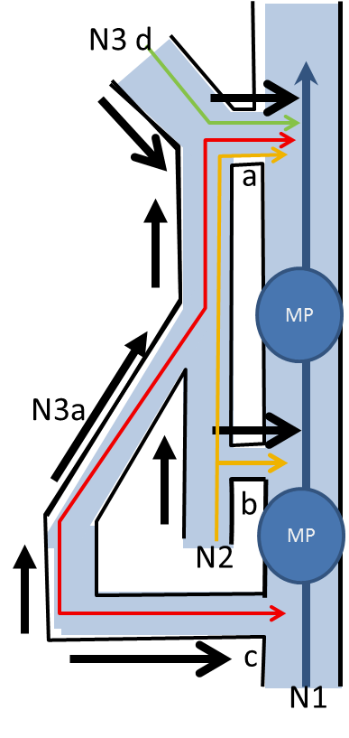
Figure 3. Venous networks hierarchy
N1: deep veins, N2: Saphenous trunks and arches, N3a: ascending GSV tributaries, N3d: descending arches tributaries, a: N2-N1 junction (here SFJ) , b: N2-N1 perforator, c: N3-N1 perforator, MP: muscular pump
Black arrow: Normal content outflow whatever the direction
Red line: normal N3a content outflow and direction, Green line: Normal N3d content and direction, Yellow line: GSV Normal content outflow and direction,
Blue line: Deep venous outflow
Normal hierarchal drainage: N3>N2>N1, N3>N1, N3>N2>N1. Here N3a>N2>N1, N3a>N1, N3d>N2>N1. This is a GSV example but can be made of SSV and any N2-N1 or N3-N1 connections.

Figure 4. Physiological Dynamic Fractionation of Hydrostatic Pressure DFHP: alternate valve closure reduces hydrostatic pressure HSP by fractioning the height of the venous blood column. Effect of the valvulo-muscular pump VMP of the calf when walking HSP: Hydrostatic pressure. h: Height of venous blood column m: calf VMP muscles. Dv : distal calf VMP valve pv: proximal calf VMP valve. a: Standing immobile. No DFPH :VMP at rest. Open VMP valves. h1: maximum height. b :Walking. DFHP: distal VMP valve closed by VMP systole. h2 : reduced eight at the dv level c: :Walking. DFHP: proximal VMP valve closed by VMP diastole. h3 : reduced eight at the pv level.
From “ Principles of l Venous Hemodynamics. C.Franceschi, P.Zamboni Nova Science Publishers 2009 “

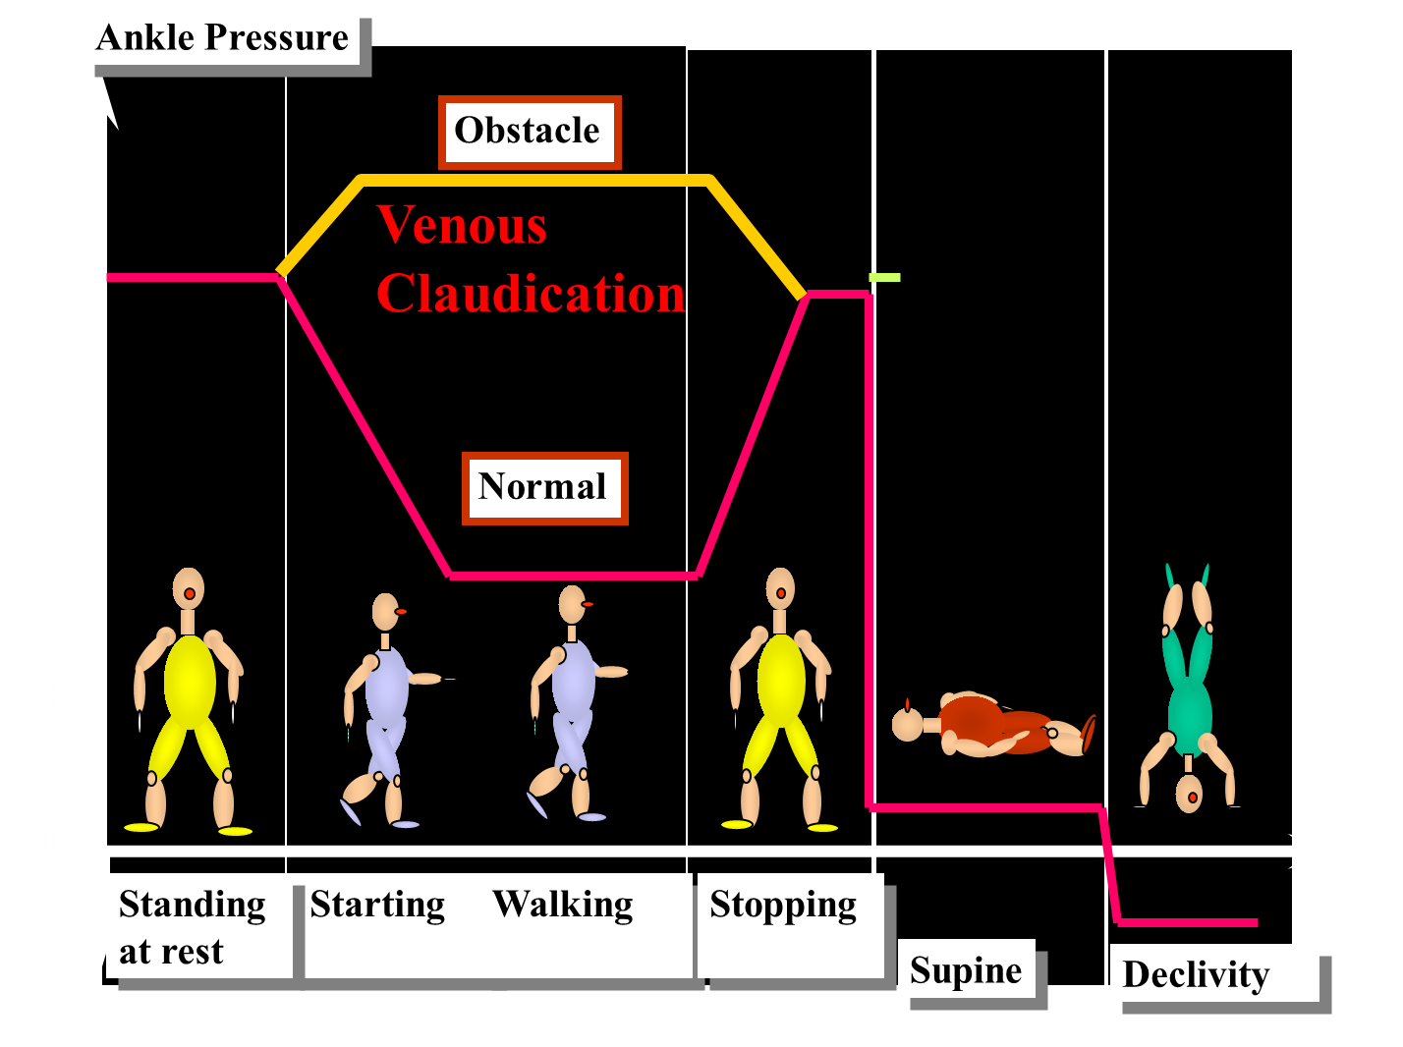
Figure 5: Venous obstruction and claudication
In case of obstruction, walking increases the flow and RP ( vasodilation) in addition to the Muscular Pump Pressure and result in venous pressure increase upstream the obstruction such as to be responsible for pain and claudication.
Figure 6. Superficial open vicarious shunts for superficial venous obstacles : Any venous draining flow suppression a ( phlebectomy, sclerosis, Laser…) raises the residual pressure in the previously drained territory, so that micro shunts are opened (matting) b , collaterals veins are forced and dilated c ( induced varicose recurrence). If the draining entry is suppressed f, the high residual pressure flow forces any collateral and reaches any perforating vein through which it drains g. In some cases, more than one perforating vein is reached and a closed shunt can be activated h. That is the key point of varicose recurrence after non haemodynamic therapy and explains why recurrent non haemodynamic therapies fail.
From “ Principles of l Venous Hemodynamics. C.Franceschi, P.Zamboni Nova Science Publishers 2009 “

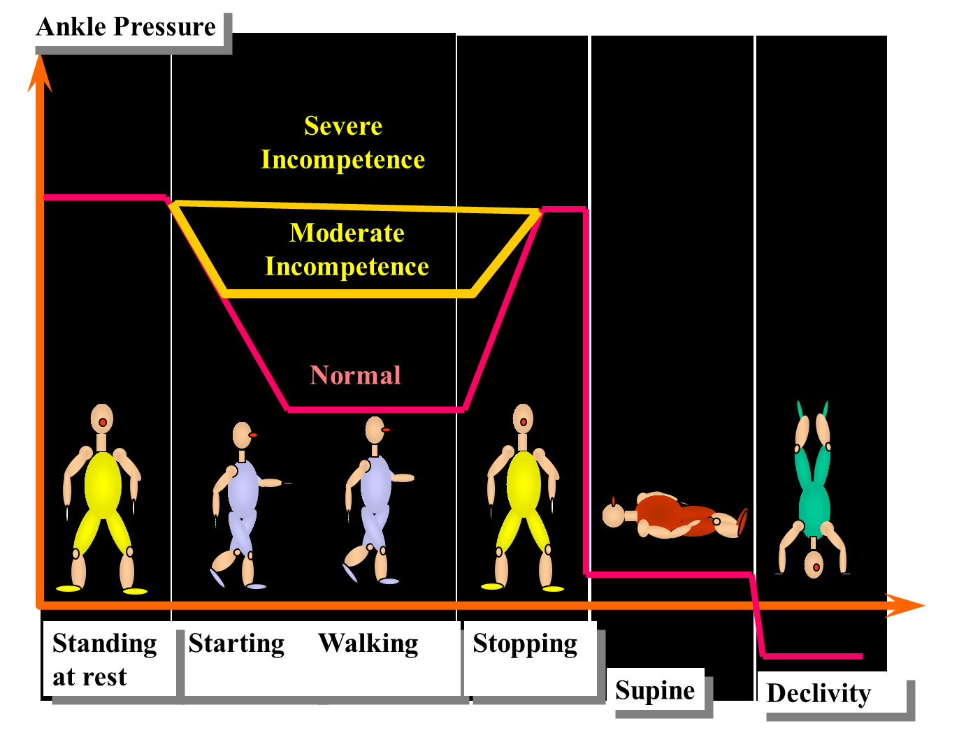Figure 7: Venous incompetence and gravitational Hydrostatic Pressure
The invasive pressure measurement at the ankle shows no difference between normal and incompetent patients in various positions (standing still, lying down and elevated extremities) while the difference is dramatic during walking-like manoeuvers (decrease down to 30 mmHg in normal when it remains high proportionally to the incompetence in the patient.

Figure 8. Impaired Dynamic Fractionation of Hydrostatic Pressure DFHP in case of deep venous incompetence DVI. Due to deep valves incompetence, valvulo-muscular pump VMP valve alternate closure is no more waterproof and does not achieve a complete fractionation of the venous blood column. h: Height of venous blood column m: calf VMP muscles. Dv : incompetent distal calf VMP valve pv: incompetent proximal calf VMP valve. a: Standing immobile. No DFPH :VMP at rest. Open VMP valves. h1: maximum height. b :Walking. DFHP: distal VMP valve remains open despite the VMP systole. h2 : no HSP reduction at the dv level c: :Walking. DFHP: proximal VMP valve remains open despite the VMP diastole. h3 : no HSP reduction at the pv level.
From “ Principles of l Venous Hemodynamics. C.Franceschi, P.Zamboni Nova Science Publishers 2009 “

Figure 9. Impaired Dynamic Fractionation of Hydrostatic Pressure DFHP in case of superficial venous incompetence SVI. Despite deep valves waterproof closure, correct DFHP is not achieved in case of superficial valves incompetence, when the incompetent superficial vein shunts the deep fractionation. h: Height of venous blood column m: calf VMP muscles. Dv : competent distal calf VMP valve pv: competent proximal calf VMP valve. sv: incompetent superficial valves. a: Standing immobile. No DFPH :VMP at rest. Open VMP valves. h1: maximum height. b,c :Walking. DFHP: distal and proximal alternately closed by VMP systole and diastole but h2 and h3 are not fractionated because of the liquid continuity through the incompetent superficial venous shunt.
From “ Principles of l Venous Hemodynamics. C.Franceschi, P.Zamboni Nova Science Publishers 2009 “

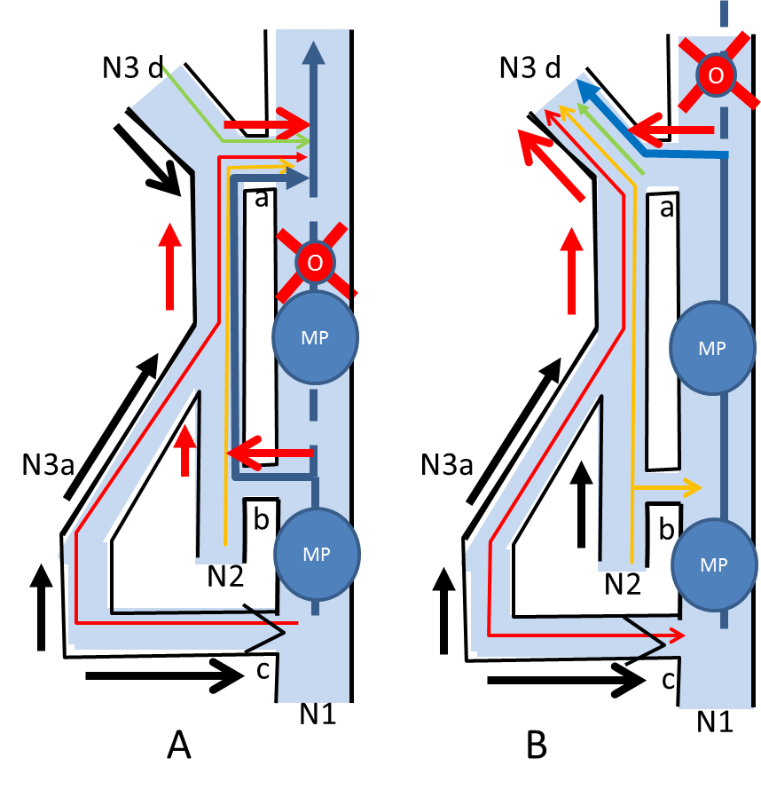
Figure 10. Open Vicarious Shunts (OVS) : overloaded by-pass collaterals.
N1: deep veins , N2: Saphenous trunks and arches, N3a: ascending tributaries, N3d: arches descending tributaries, a: N2-N1 junction ( here SFJ) , b: N2-N1 perforator, c: N3-N1 perforator, MP: muscular pump, o:obstacle.Black arrow: Normal outflow whatever the direction, Red arrow: Overloaded flow whatever the direction. Red line: normal N3a outflow whatever the direction, Green line: Normal N3d outflow the direction, Yellow line: Normal GSV outflow whatever is direction , Blue line: Deep venous outflow
A: obstacle to the flow (O) (here femoral vein) , Open Vicarious Shunt ( N1> escape point (refluxing perforator c) > antegrade N2 ( GSV and SFJ) then antegrade re-entry a but overloaded by N1flow.
B: obstacle to the flow (O) (here iliac vein) , Open Vicarious Shunt ( N1> refluxing SFJ (escape point) and N3d d overloaded by N1, N3a and N2 ), re-entry >N1 not exhibited ( can be through the antegrade opposite GS arch and SFJ then into the opposite femoral vein.

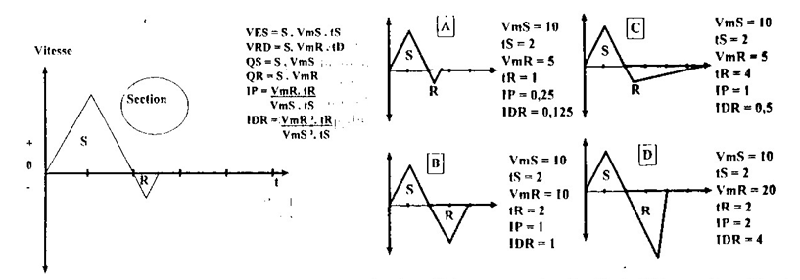
Figure 11. Reflux volume assessment
VES: Antegrade Systolic volume, VRD: Reflux Diastolic volume, VmS: Systolic Mean velocity, VmR: Diastolic Mean velocity , tS: Systolic time, tR: Diastolic time, QS: Systolic flow volume, QR: Diastolic flow volume. IP: Psatakis Index, IDR: Dynamic Reflux Inde.
A: Physioloc reflux B: Total reflux C: Partial reflux D: Closed shunt reflux

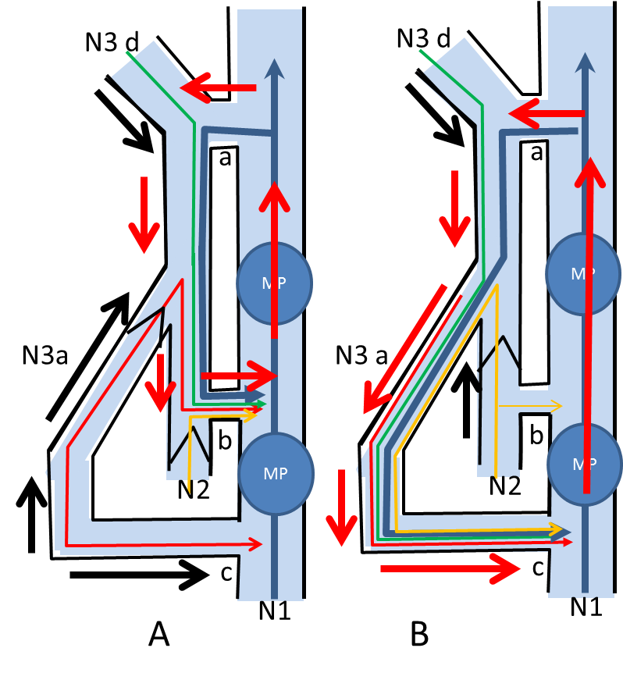
Figure 12. Closed shunts (CS) : overloaded closed circuit
N1: deep veins , N2: Saphenous trunks and arches, N3a: ascending tributaries, N3d: arches descending tributaries, a: N2-N1 junction ( here SFJ) , b: N2-N1 perforator, c: N3-N1 perforator, MP: muscular pump, o:obstacle.Black arrow: Normal outflow whatever the direction, Red arrow: Overloaded flow whatever the direction. Red line: normal N3a outflow whatever the direction, Green line: Normal N3d outflow the direction, Yellow line: Normal GSV outflow whatever the direction , Blue line: Deep venous outflow
A: CS type 1: MP Diastolic phase: N1>N2>N1. Here N1 overloading SFJ a (escape point) and GSV refluxing down to antegrade perforator b ( re-entry) then into N1.
B: CS type 3: MP Diastolic phase: N1>N2>N3>N1. . Here N1 overloading SFJ a (escape point) and GSV refluxing down into a refluxing tributary N3 then to antegrade re-entry perforator c then into N1

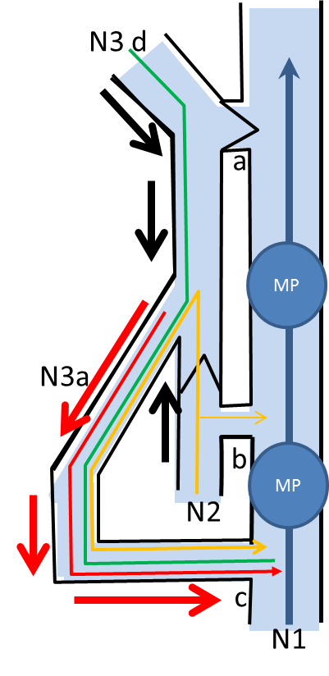

Figure 13. Open Deviated shunts (ODS) :

N1: deep veins , N2: Saphenous trunks and arches, N3a: ascending tributaries, N3d: arches descending tributaries, a: N2-N1 junction ( here SFJ) , b: N2-N1 perforator, c: N3-N1 perforator, MP: muscular pump, o:obstacle.Black arrow: Normal outflow whatever the direction, Red arrow: Overloaded flow whatever the direction. Red line: normal N3a outflow whatever the direction, Green line: Normal N3d outflow the direction, Yellow line: Normal GSV outflow whatever the direction , Blue line: Deep venous outflow
ODS type 2: MP Diastolic phase: N2>N3>N1. . Here GSV trunk N2 > refluxing N3 then to antegrade re-entry perforator c then into N1. Contrary to CS, it is not overloaded by N1, but only by part of GSV.

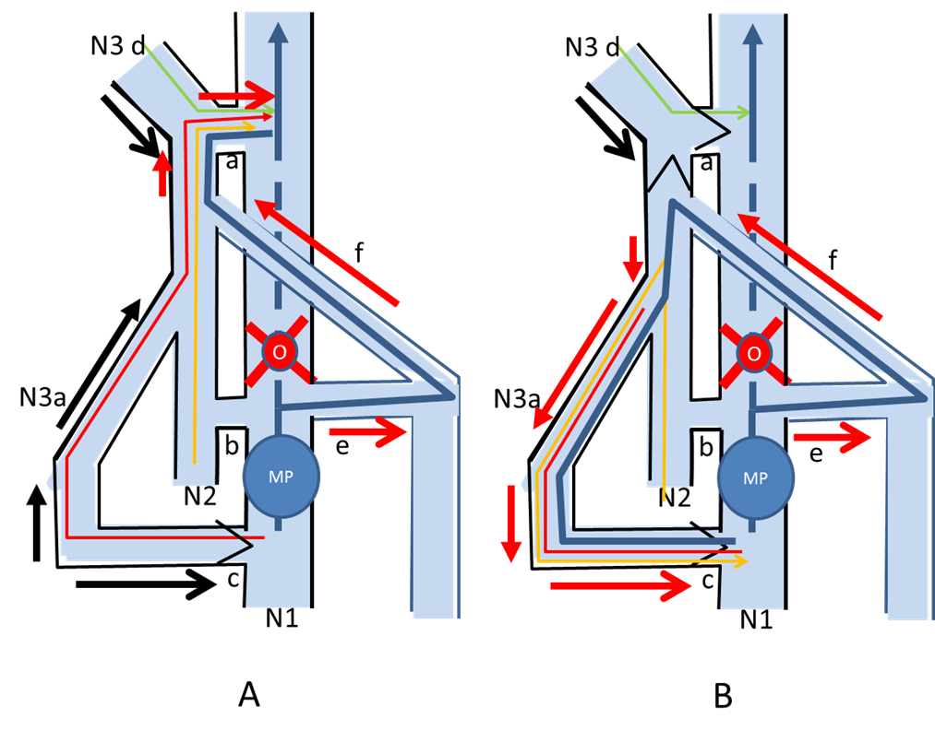

Figure 14. Mixed shunts (MS) : Playing the role of OVS in systole and CS in diastole of the MP
N1: deep veins , N2: Saphenous trunks and arches, N3a: ascending tributaries, N3d: arches descending tributaries, a: N2-N1 junction ( here SFJ) , b: N2-N1 perforator, c: N3-N1 perforator, e: SPJ, f: Giacomini vein, MP: muscular pump, o:obstacle.Black arrow: Normal outflow whatever the direction, Red arrow: Overloaded flow whatever the direction. Red line: normal N3a outflow whatever the direction, Green line: Normal N3d outflow the direction, Yellow line: Normal GSV outflow whatever is direction , Blue line: Deep venous outflow
A: MP systole: OVS activated. obstacle to the flow (O) (here femoral vein) , Open Vicarious Shunt ( N1> refluxing SPJ and SSV arch > antegrade N2 ( Giacomini f)> antegrade GSV proximal segment and SFJ (re-entry a > N1.
B: MP diastole: CS type 3 activated( N1> refluxing SPJ and SSV arch > antegrade N2 ( Giacomini f)> refluxing GSV segment> refluxing N3a> re-entry c >N1.

In MS, OVS and CS have the same escape point (here SpJ) and a common proximal refluxing pathway (here the arch) and antegrade Giacomini but their distal segment and re-entry are different : antegrade GSV proximal segment and SFJ (re-entry a > N1 for the OVS and
refluxing GSV segment> refluxing N3a> re-entry c >N1 for CS.

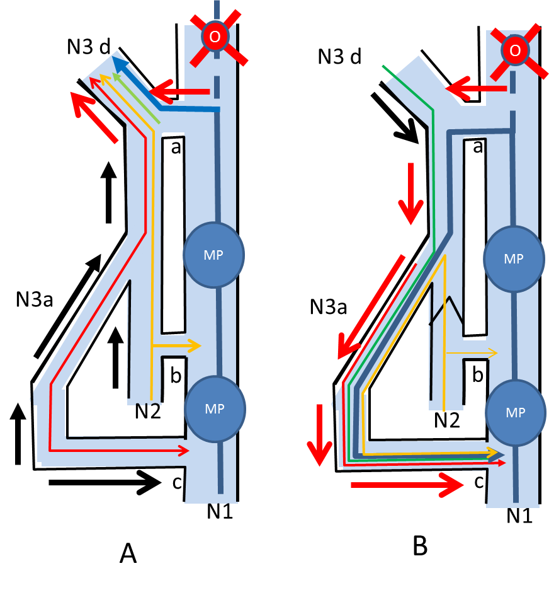
Figure 15. Mixed shunts (MS) : Playing the role of OVS in systole and CS in diastole of the MP

N1: deep veins , N2: Saphenous trunks and arches, N3a: ascending tributaries, N3d: arches descending tributaries, a: N2-N1 junction ( here SFJ) , b: N2-N1 perforator, c: N3-N1 perforator, MP: muscular pump, o:obstacle.Black arrow: Normal outflow whatever the direction, Red arrow: Overloaded flow whatever the direction. Red line: normal N3a outflow whatever the direction, Green line: Normal N3d outflow the direction, Yellow line: Normal GSV outflow whatever the direction , Blue line: Deep venous outflow
Iliac vein obstacle O. GSV varicosis.
A: MP systole: OVS activated. obstacle to the flow (O) (here iliac vein) , Open Vicarious Shunt ( N1> refluxing SFJ and N3d d overloaded by N1, N3a and N2 ), re-entry >N1 not designed ( can be through the antegrade opposite GS arch and SFJ then into the opposite femoral vein.
B: MP diastole: CS type 3 activated. N1>N2>N3>N1. . Here N1 overloading SFJ a (escape point) > Arch and GSV refluxing down into a refluxing tributary N3 then to antegrade re-entry perforator c then into N1
In MS, OVS and CS have the same escape point (here SFJ) and a common proximal refluxing pathway (here the arch) but their distal segment and re-entry are different : N3d up to the opposite femoral vein for the OVS and N2>N3 down to perforator c for CS.

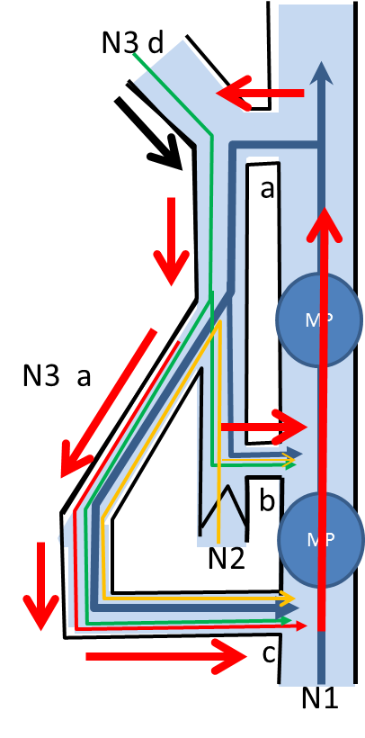
Figure 16: Composite shunt Shunt 1+2
N1: deep veins , N2: Saphenous trunks and arches, N3a: ascending tributaries, N3d: arches descending tributaries, a: N2-N1 junction ( here SFJ) , b: N2-N1 perforator, c: N3-N1 perforator, MP: muscular pump, o:obstacle.Black arrow: Normal outflow whatever the direction, Red arrow: Overloaded flow whatever the direction. Red line: normal N3a outflow whatever the direction, Green line: Normal N3d outflow the direction, Yellow line: Normal GSV outflow whatever the direction , Blue line: Deep venous outflow
Composite shunt N1>N2>N1 + N2>N3>N1 :
Common escape point (here SFJ a) . Shunt 1 : N2 overloaded by N1 and re-entry N2-N1 b. Shunt 2 : N3 overloaded by N1, and N2 with re-entry c.
Notice the difference with Shunt 3 where there is no re-entry located on N2 : this difference is important to the choice of the conservative- hemodynamic therapeutic strategy.

,Figure 17. Pitot’s tubes. Parameters of pressure. F: flow P: pressure. 1: P= Static pressure + dynamic pressure. 2: P= Static pressure.3: P= Static pressure - dynamic pressure ( Venturi effect). If 1,2 and 3, are catheters, one can see that for the same Total Pressure TP, the pressure values are different and depend on the orientation of their tip according to the flow F direction and velocity. The flow velocity in this case depends on the resistances to the flow. A: Flow velocity = 0, Resistance > or = TP, so all the TP is converted in Static pressure. B: Flow velocity = medium value, moderate Resistance <TP, so TP is converted. In tube 1 , were the tip is oriented in the opposite direction but parallel to the flow, the pressure value is related to the total pressure ie. dynamic pressure + lateral(static) pressure + hydrostatic (gravity) pressure where hydrostatic pressure is negligible because the tube is horizontal. In tube 2, where the tip is perpendicular to the flow, the pressure value is total pressure – dynamic pressure ie. represents the pressure applied against the wall of the tube. Venturi effect is shown in tube 3 were the tip is oriented in the same direction and parallel to the flow. This drawing up effect can be efficient for tributaries drainage but as far as the velocity is high enough. C: Flow velocity = high value, low Resistance <TP. TP converted in the same way as B, but lateral pressure is lower and Venturi effect more pronounced.

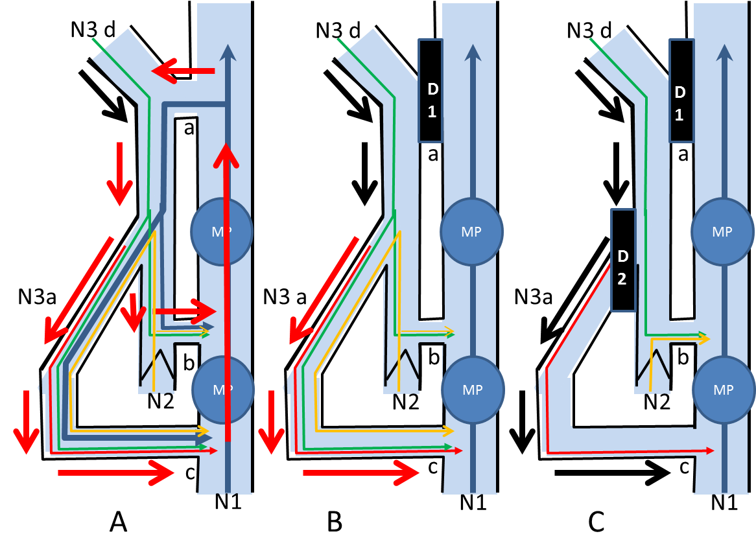
Figure 18: Hemodynamic and conservative strategy and hemodynamic outcomes: an example of composite GSV shunts treatment.
N1: deep veins , N2: Saphenous trunks and arches, N3a: ascending tributaries, N3d: arches descending tributaries, a: N2-N1 junction ( here SFJ) , b: N2-N1 perforator, c: N3-N1 perforator, MP: muscular pump, o:obstacle.Black arrow: Normal outflow whatever the direction, Red arrow: Overloaded flow whatever the direction. Red line: normal N3a outflow whatever the direction, Green line: Normal N3d outflow the direction, Yellow line: Normal GSV outflow whatever the direction , Blue line: Deep venous outflow
D1: N1-N2 disconnection, D2: N3-N3 disconnection
GHP fractionation ( D1) restores the DHPF at the groin level and disconnections suppress the CS N1>N2>N1. In that case, the remaining ODS shunt 2 N2>N3a>N1 is fractionated and disconnected (D2) . Conservation respects the N2 and N3 outfows ( in order to avoid the consequent OVS) while the overloading flows are suppressed (see the colored lines) . The previous inverted hierarchal flow N1>N2 and N2-N3 (A) in restored in physiological N2>N1 (B) and N3-N1 (C) despite its “abnormal” but not hemodynamically pathological retrograde flow.

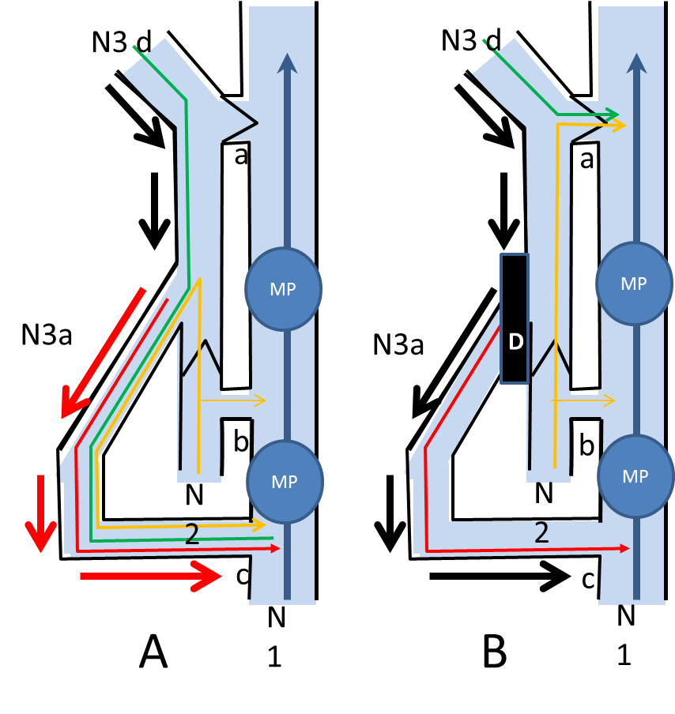
Figure 19: Hemodynamic and conservative strategy and hemodynamic outcomes: an example of shunt 2 treatment
N1: deep veins , N2: Saphenous trunks and arches, N3a: ascending tributaries, N3d: arches descending tributaries, a: N2-N1 junction ( here SFJ) , b: N2-N1 perforator, c: N3-N1 perforator, MP: muscular pump, o:obstacle.Black arrow: Normal outflow whatever the direction, Red arrow: Overloaded flow whatever the direction. Red line: normal N3a outflow whatever the direction, Green line: Normal N3d outflow the direction, Yellow line: Normal GSV outflow whatever the direction , Blue line: Deep venous outflow
D: N2-N3 disconnection:
GHP fractionation ( D1) restores the DHPF at the mid thigh level and disconnection at the same place . N3a is no more overloaded by N2 and the previous inverted hierarchal flow N2-N3a (A) in restored in physiological N3a-N1 (B) despite its “abnormal” but not hemodynamically pathological retrograde flow.

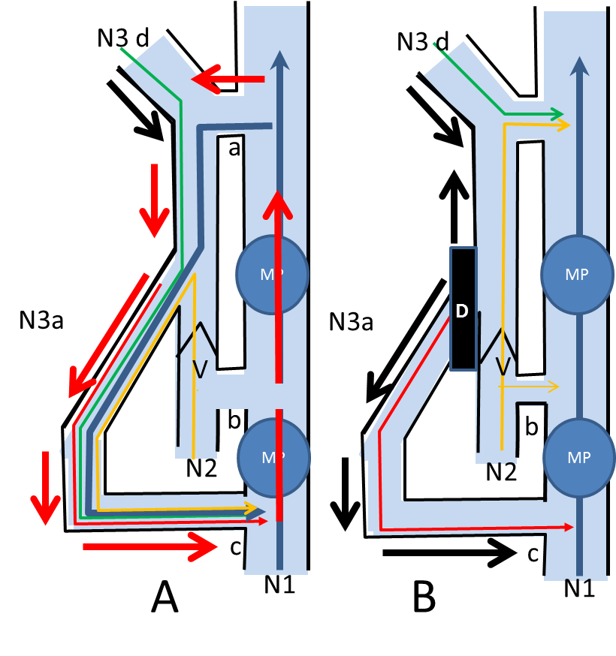
Figure 20: Hemodynamic and conservative strategy and hemodynamic outcomes: an example of shunt 3treatment
N1: deep veins , N2: Saphenous trunks and arches, N3a: ascending tributaries, N3d: arches descending tributaries, a: N2-N1 junction ( here SFJ) , b: N2-N1 perforator, c: N3-N1 perforator, MP: muscular pump, o:obstacle.Black arrow: Normal outflow whatever the direction, Red arrow: Overloaded flow whatever the direction. Red line: normal N3a outflow whatever the direction, Green line: Normal N3d outflow the direction, Yellow line: Normal GSV outflow whatever the direction , Blue line: Deep venous outflow
D: N1>N2>N3>N1 CS = shunt 3 ( A) N2-N3 disconnection (B)
First step of CHIVA 2 steps. N2-N3 disconnection (B). The SFJ and GSV segment below the SFJ are no more refluxing (no more flow down through the disconnected N3-N2 junction) and the antegrade direction is restored (B)) .Thanks to the N1 CS overload, the caliber of the GSV trunk is reduced despite a reamaining unfractionated overlying GHP column. This remaining too high GHP leads to frequent GSV reappearance by forcing the distal competent GSV down to a a saphenous trunk perforator (re-entry) changing the previous Shunt 3 in Shunt 1, that is treated by SFJ disconnection ( second step of CHIVA 2 steps).

