Chapter 2.
Basic Science in Venous Hemodynamics

Coordinate: Kirk Beach
Kirk Beach kwbeach@uw.edu
Fausto Passariello vasculab@yahoogroups.com
Assist to write:
Nicos Labropoulos, nlabrop@yahoo.com,
Claudio Allegra, ' allegra@mclink.it,
Claude Franceschi claude.franceschi@gmail.com,
Review:
Andrew Nicolaides anicolaides1@gmail.com,
Byung Boong Lee bblee38@gmail.com

INTRODUCTION

The conduit of the femoral vein conveys 2.5 cm³/s of blood towards the heart at rest to support baseline tissue metabolism; at maximum metabolic demand, and average of 15 cm³/s is conveyed [Landowne, 1942]. The conduit, with a circular diameter of 10 mm when fully inflated, collapses into a flattened shape at lower intraluminal pressure, with the perimeter (p) diminishing from 36 mm to 25 mm as the cross sectional area (a) diminishes from 100 to 26 sq mm (Figure 1) resulting in a change in hydraulic diameter (D = 4a/p) from 11 to 4 mm. The resulting Reynolds numbers ( Re = D Q ρ/a μ ) for mean flows (Q) is well below 1000 (Table 1), but can exceed the turbulent threshold of 2300 when subject to proximal compression maneuvers causing high instantaneous flow rates (Figure 2).

Table 1 Properties of Femoral Vein at Three Different Luminal Pressures based on Experiment and Published Flow Rates with Computed Reynolds Numbers and Velocities
 |  |  |  | 2.5 cm³/s | 15 cm³/s
Pressure | Area | Perimeter | Hydraulic Diameter | Resting Flow | Hyperemic Flow | Velocity | Velocity
cmH₂O | mm² | mm | mm | Re | Re | cm/s | cm/s
-16 | 26 | 25 | 4 | 126 | 757 | 9.5 | 57.0
0 | 92 | 36 | 10 | 89 | 531 | 2.7 | 16.2
17 | 100 | 36 | 11 | 88 | 529 | 2.5 | 15.0

Except at high flow rates from compression, the low Reynolds numbers in straight conduits are consistent with plug flow evolving to parabolic flow in the elliptical and biconcave cross sections. Computation of the relationship between pressure gradient and flow rate in a simple model the flaccid venous conduit is futile because of the relatively large effects on geometry of the solid tissue structures.

The femoral vein is contained in a “compartment” pressure vessel along with surrounding muscles, and adjacent artery and nerve confined by the anterior compartment fascia. The intraluminal venous pressure varies with elevation relative to the right atrium due to hydrostatic pressure interrupted by any closed intervening venous valves. Thus the intraluminal may vary from zero (when the vein is elevated above the heart) to the sum of the right atrial pressure (central venous pressure) plus the elevational difference between the vein and the atrium times the density of blood.

p = CVP + ρ ΔE

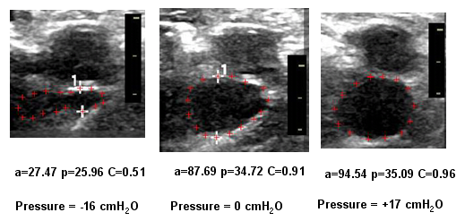
Figure 1 Vein Cross Section at Different Pressures
Pressure computed based on 60 cm distance from right atrium to measurement location, and bed tilt at 15 degrees head up (-16 cmH₂O) or 16 degrees head down (+17 cmH₂O)
Circularity (C = 4 π a / p² ) equals 1 for maximum (circular) cross section for perimeter.
Image by Jean Hadlock, University of Washingotn

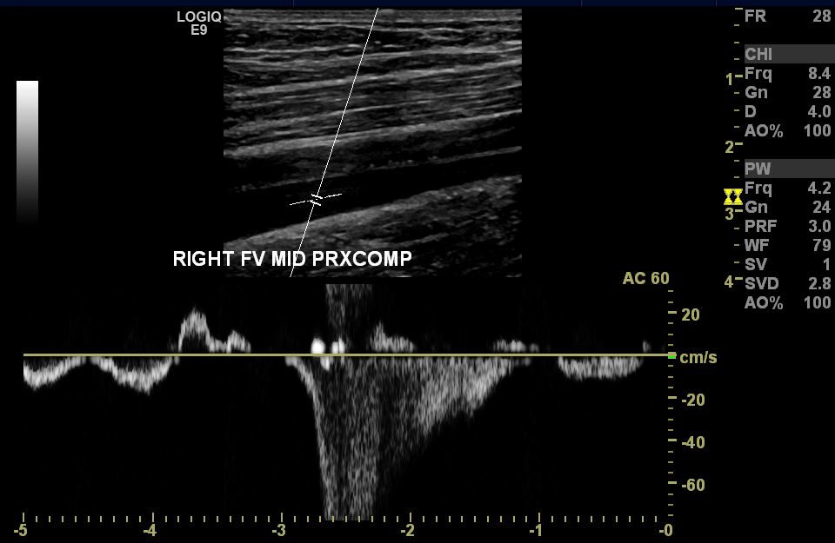
Figure 2 Venous Velocity with release of Proximal Compression
Normal laminar parabolic flow peak = 12 cm/s, temporal & spatial mean = 3 cm/s results in a resting flow rate of 2.36 cm³/s and a Reynolds number of 386 consistent with laminar flow. The peak (aliased) velocity of 85 cm/s with spectral broadening on deceleration indicating turbulent flow consistent with the peak Reynolds number exceeding 2700, which would be greater if the vein were not inflated to circular cross section.
Image by Jean Hadlock, University of Washingotn

p = (25 (cmH₂O)[Hooker 1916 age 65] + 1.025 [gm/cm³ Blood] 60 cm )/ 13.534 [gm/cm³ Hg]

p = 64 mm Hg

The transmural pressure inflating the vein is the intraluminal pressure minus the compartment pressure.

The term “compliance” (Φ= Δal/Δp ) is commonly used to express relationship between intravascular pressure and volume. Compliance only has utility when the volume (cross sectional area for constant length) is proportional to the pressure, or at least linearly related to the pressure, which is not the case in veins (Figure 3 left).

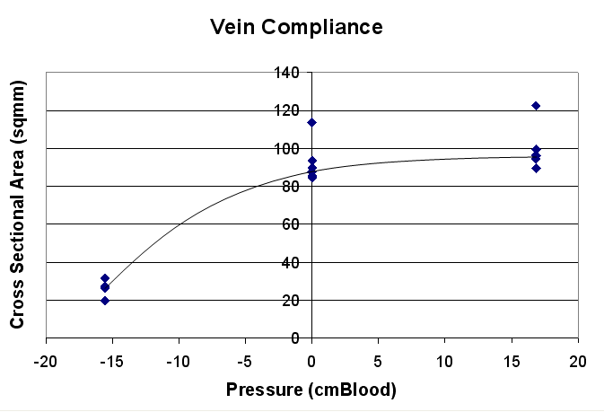 | 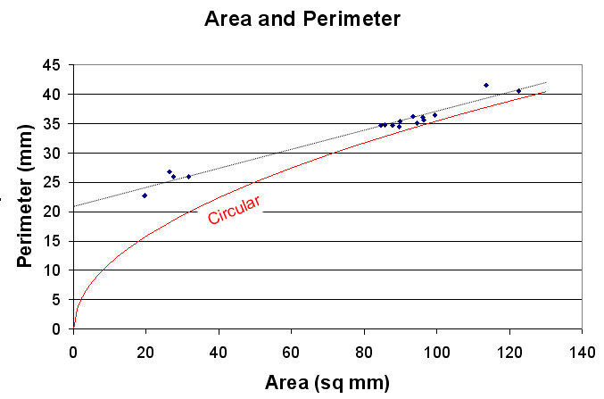
Figure 3 Venous Pressure vs Volume, and Area vs Perimeter.
LEFT Venous cross section remains nearly constant in an inflated nearly circular vein when the transmural pressure is positive, with negative pressure the cross sectional area drops toward zero as the vein collapses.
RIGHT As the venous volume decreases by 80%, the perimeter decreases by 30%, a considerable deviation from a circular shape (red). A linear extrapolation of the venous perimeter to 21 mm is not valid cause the forces that determine the shape depend on wall mechanics.

The computation of circumferential vessel wall tension is often expressed using the law of LaPlace. This is commonly computed using circular model (Figure 4A). The dilating force on the hemicircular section of length “l” (p r l ) is equal to the wall tension (T l ). More generally, this relationship is also valid for any curved section of the wall (Figure 4B) of angular width α; the force on the section is ( p r sin(α/2) l ) and the component force of the wall tension is (T l sin(α/2) ) providing the same result T = p r . The pressure in this computation is the transmural pressure (p_{vein} – p_{surround}).

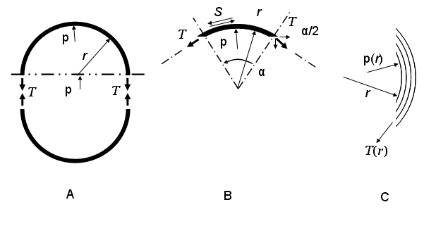
Figure 4 Vascular Wall Tension and Stress

In a deflated vein (Figure 1 left), the biconcave shape has a negative radius indicating that the pressure outside the vein (p_{surround} ) is greater than the pressure inside the vein (p_{vein} ). Often the concave portions of the vein wall are constrained by solid tissue, and the tension can be altered by shear forces (S) in Fig. 4B. If the surface is well lubricated, then the shear forces are absent and the wall tension is uniform around the perimeter. However, this does not mean that the transmural pressure is uniform. In the case of the collapsed vein in Fig. 1A, the superficial and deep surrounding pressures exerted by the solid tissues are high relative to the lateral pressure where the small radius edges tend to dissect between the apposed muscles.

A similar force balance can be used to compute the longitudinal tension. The longitudinal wall force is ( 2 π r ψ ) where “ψ” is the longitudinal wall tension. This is balanced by the longitudinal pressure force ( p a ) where the circular cross section (a) circular cross section is ( π r² p ). So for a circular cross section, ψ = p r / 2. But for the deflated vein, the longitudinal tension is much lower because the cross section is lower.

The force balances also applies within the wall (Figure 4C) using continuous variables depending on the radius (dT (r)./ dr = r dp(r)/dr ). Computations based on a simple elastic model relating stress to strain show that the pressure changes linearly from the lumen to the external wall. However, the histology of the venous wall reveals a layered structure, intima, elastic lamina [Chang 2009], media and adventitia perforated by vasa vasorum. Each layer will have different mechanical properties. In addition, the model depicted in Fig 4C does not include shear forces between the layers, which can be ignored in an axisymmetric model, but contribute stiffness that accounts for the non-zero radius at the lateral margins of the deflated vein in Fig. 1Left.

The oxygenation of the venous wall [O’Neill, 1947] (as in the case of the arterial wall) is supplied by diffusion from the luminal blood and perfusion from the vasa vasorum. Compared to the arterial wall, the venous wall is thin (0.5 mm vs 2.5 mm ) and the oxygen saturation of the luminal blood is depleted ( 60% to 80% vs 97% arterial) resulting in a diminished partial pressure driving potential for oxygen diffusion (33 to 48 mmHg vs 160 mmHg). Even though the metabolic requirements of the muscular layers are low, the importance if the venous vasa vasorum delivering oxygenated blood to the wall is important, providing a relatively constant supply compared to the luminal fluctuating oxygenation. The hemodynamic pressure in the vasa Vasorum is estimaged as 17 mmHg [Simon, 1973], although accurate measurements are absent from the literature. This pressure and the Vasa Vasorum volume fraction in the adventitia together have a major role in the mechanical properties of the wall.

Intelligent design would place deep venous unidirectional valves at locations where the deep vein penetrates compartment fascia from a low pressure compartment to a high pressure compartment so that the valve would act to prevent flow down this pressure difference. Because the orifice of the bi-leaflet valve is oriented parallel to the intramuscular plane and perpendicular to the axis of collapse, the leaflets can easily coapt when the vein is compressed, but the leaflet width might be less than the radius when the vein is inflated to circularity, resulting in venous valve regurgitation.
During ambulation, a sequence of muscle compressions drives the blood from the lower leg through the trichamber (or parallel pentichamber) pump extending from the ankle through the lower and upper leg and the pelvic compartments to the confluence of the common iliac veins. The sequence of compressions is revealed by studying electromyographic tracings from the anterior and posterior compartments of each leg segment during walking [Queralt 2009]. Examining the compression sequence highlights the critical occlusion times required of the intra-compartmental venous valves.

PRACTICAL APPLICATIONS
There are four pathophysiological venous diseases: 1) Deep Venous Thrombosis (DVT) leading to pulmonary embolus, 2) venous valvular incompetence (insufficiency) leading to venous hypertension and cutaneous leg ulceration, 3) venous outflow obstruction leading to venous claudication, 4) compartmental edema or containment restriction leading resulting in venous collapse known as compartment syndrome leading to muscular ischemia and necrosis. Each of these processes can be detected by conventional and advanced art noninvasive diagnostic methods and treated by conventional and/or advanced methods. Only the advanced art methods will be mentioned here.

********** PLEASE NOTE THAT SOME OF THE FOLLOWING CONTAINS POSSIBLE INNOVATIONS THAT MIGHT BECOME PROTECTED INTELLECTUAL PROPERTY. PLEASE DO NOT DISCLOSE PUBLICALLY OR WITHOUT PERMISSION TO PRESERVE THOSE INTELLECTUAL PROPERTY RIGHTS. ******************

DEEP VENOUS THROMBOSIS: Although noninvasive methods for diagnosing DVT have evolved over half a century, all are designed for laboratory use rather than for ambulatory applications applicable to the majority of activity and none are designed to detect thromboembolic events. Transcranial Doppler monitoring of the middle cerebral artery for thromboemboli, atheroemboli and bubbles has achieved some acceptance in medical practice. The technique depends on the use of lower ultrasound frequencies (~1 MHz) to display the embolic Doppler echo signals at amplitudes above the blood Doppler echoes. An ultrasonic path to the inferior vena cava might exist through the left ilium via the left psoas major muscle offering the aorta as a convenient aiming target (3 cm deeper). Of course, the advantage of using the artery as an aiming beacon is that it will be consistently inflated with high velocity blood. The boney pelvis might offer a stable platform for mounting a transducer that could be used for continuous embolus monitoring. Embolus monitoring might be useful in the management of DVT.

VENOUS VALVE INCOMPETENCE: One noninvasive test of venous valve reflux is the use of a photo-plethysmograph to record venular refilling on the dorsum of the foot [Abramowitz-1979]. This test has the disadvantage of assessing the entire leg, or more specifically of the calf, but does not asses incompetence in of more proximal valves. The cutaneous venules of the entire leg are drained via local perforators into the deep venous system, and thus, in principle, should exhibit a similar response to the foot veins. The venular blood can be differentiated from the arteriolar blood by measuring the oxygen saturation, but not by oscillation frequency as on walking, the gait frequency and the heart rate are similar. An ambulatory monitor consisting of reflectance pulse oximeter optics with integrated accelerometer to monitor gait, and a remote PPG (ear) to monitor heart rate coupled to an analysis system to separate the heart rate synchronized signal from the gait synchronized signal and to verify that the gait synchronized signal represents deoxygenated blood. With this apparatus, assuming that the perforator veins effectively couple to the deep system, the competence of proximal deep venous valves should result in lowering the cutaneous venular optical density. This system should work over each of the compartments of the leg, showing competence in the underlying compartment and should be equally effective in the uncovered skin as for the skin contained in a compression stocking.

Several techniques have been used for the repair of incompetent venous valves [Raju 1996] with limited success. One method involves constraining the valve ring with a sleeve. However, reducing the ring diameter which is parallel to the orifice axis serves to reduce the leaflet tension and might increase regurgitation, while reducing the cross axis diameter with an elliptical constraint would serve to bring the leaflets into apposition without reducing leaflet tension, thereby improving valve competence. Application of pressure to the entire, such as achieved with compression stockings, also tends to collapse the vein in the cross-axis direction, improving valve function.

VENOUS OUTFLOW OBSTRUCTION=VENOUS CLAUDICATION:

COMPARTMENT SYNDROME: Current diagnosis of compartment syndrome involves the invasive measurement of compartment pressure. However, Doppler of the compartment veins reveals no respiratory phasicity variation signal at rest, but a flow signal in response to distal compression [Turnipseed-1995, Singh-2006]. A similar lack of respiratory volume change should be detected by plethysmography. The most promising Plethysmographic method is ultrasonic plethysmography [Beach, 1992-1994]

BLOOD FLOW AND VISCOSITY
Experimental studies of venular blood flow in 0.05 mm venules at velocities of 5 mm/s show laminar streaming [Bishop, 2001] facilitating the transport of vasoactive signaling molecules along the wall. Computational solutions in larger tubes show quadrahelical flow after confluences as expected [Cros, 2002].

CLIPS OF TEXT #######################################################

The linear concepts of Resistance and Impedance have similar limitations in hemodynamics; computations are simplified if the pressure gradient vs flow rate are used.

(at 0 pressure) and increases linearly with age (based on venous collapse) to that pathological threshold of 30 cmWater at age 100 [Hooker 1916], and equally high during post-exercise reactive hyperemia.
[Schwartz 1989]

Logically the valves are expected to be located where the veins pass from one compartment to another.

OUTLINE
a. Flow through collapsible tubes

b. Resistance and Impedance

c. The venous wall

i. The Young-Laplace law and the container geometry

Cylinder T=Pr
Sphere T=Pr/2 and the longitudinal stress

Young–Laplace equation - Wikipedia, the free encyclopedia en.wikipedia.org/wiki/Young–Laplace_equationCached - Similar
You +1'd this publicly. Undo Transmural Pressure (soap films)
In physics, the Young–Laplace equation is a nonlinear partial differential

ii. Caliber of the vein

iii. Compliance

iv. The volume/pressure relationship

v. The 0-pressure volume problem in compliance graphs

d. Pressure: hydrostatic gravitational pressure, residual pressure , muscular pump pressure, pressure gradients. (Claude Franceschi)

e. Viscosity

f. Energy (Claude Franceschi)

REFERENCES

Abramowitz HB, Queral LA, Finn WR, Nora PF Jr, Peterson LK, Bergan JJ, Yao JS.
The use of photoplethysmography in the assessment of venous insufficiency: a comparison to venous pressure measurements. Surgery. 1979 Sep;86(3):434-41.

Beach KW, Phillips DJ, Kansky J, Ultrasonic plethysmograph, US Patents 5,289,820 5,183,046 5,088,498 , http://patft.uspto.gov 1992-1994

Bishop, JJ, Popel AS, Intaglietta M, Johnson PC, Effect of erythrocyte aggregation and venous network geometry on rec blood cell axial migration, Am J Physiolo Heart Circ Physio 281:H939-H950, 2001.

Chang CJ, Chen CC, Hsu LA, Chang GJ, Ko YH, Chen CF, Chen MY, Yang SH, Pang JHS, Degradation of the Internal Elastic Laminae in Vein Grafts of Rats with Aortocaval Fistulae, Am J Pathology, 174:5, pp 1837-1846 2009.

Cros F, Flaud P, Dantan Ph, A digital model for the venous junctions, Computer Methods in Biomechanics and Biomedical Engineering, V5pp421-429, 2002

Dauber D, Landowne M, Katz LN, Weinberg H., Effects Of Interrupting And Restoring The Circulation To The Lower Extremities., J Clin Invest. 1942 Jan;21(1):47-56.

Hooker DR, The Influence of Age Upon the Venous Blood Pressure in Man, Am. J. Physiol. 40: 43, 1916.

Hooker DR, Observations on the Venous Blood Pressure in Man, Am. J. Physiol. 35(1): 73-86, 1914

Landowne, Milton, Dynamics of Flow Flow in Thromboangitis Obliterans, American Heart Journal, 50-68, 1942.

O'Neill, James F., The Effects on Venous Endothelium of Alterations in Blood Flow Through the Vessels in Vein Walls, and the Possible Relation to Thrombosis, Annals of Surgery. 126(3):270-288, September 1947.

Queralt A, Valls-Solé J, Castellote JM., Speeding up gait initiation and gait-pattern with a startling stimulus., Gait Posture. 2010 Feb;31(2):185-90. Epub 2009 Nov 13.

Raju W, Fredericks RK, Neglen PN, Bass JD, Durability of venous valve reconstruction techniques for ”primary” and postthrombotic reflux, J Vasc Surg, 23:357-367, 1996.

Simon BR, Kobayashi AS, Wiederhielm CA, Strandness, DE, Deformation of the Arterial Vasa Vasorum at Normal and Hypertensive Arterial Pressure, J Biomechanics V6 pp 349-359, 1973

Singh N, Siddawy AN, Bottoni CR, Antedomenico E, Gawley TS, Harada D, Gillespie DL, Uyehara FT, Cordts PR, Physiological Changes in Venous Hemodynamics Associated with Electrive Fasciotomy, Ann Vasc Surg 20: 301-305, 2006.

Turnipseed WD, Hurschler C, Vancerby R, The effects of elevated compartment pressure on tibial arteriovenous flow and relationship of mechanical and biochemical characterists of fascia to genesis of chronic anterior compartment syndrome, J Vasc Surg 21:810-817, 1995.

NOTES

Dauber D, Landowne M, Katz LN, Weinberg H., Effects Of Interrupting And Restoring The Circulation To The Lower Extremities., J Clin Invest. 1942 Jan;21(1):47-56.
LE vein pressure 11 cmH2O

Leg Dimensions 50 cm x 10 cm = =5000 cc
Vein 10 mm diameter

Landowne, Milton, Dynamics of Flow Flow in Thromboangitis Obliterans, American Heart Journal, 50-68, 1942.
Normal Flow = 3 cc/min/100cc
Normal Hyperemic Flow Increase = 14 cc/min/100cc
Normal Hyperemic Flow 17 cc/min/100cc

EMAILS ******************

Date: Tue, 12 Jun 2012 14:54:33 -0400
From: bblee <bblee38@comcast.net>
To: afunzionale@tiscali.it, kwbeach@u.washington.edu
Subject: RE: Chapter 2 Consensus of Hemodynamics
Parts/Attachments:
1 OK ~90 lines Text (charset: UTF-8)
2 Shown ~199 lines Text (charset: UTF-8)
----------------------------------------

[ The following text is in the "UTF-8" character set. ]
[ Your display is set for the "ANSI_X3.4-1968" character set. ]
[ Some characters may be displayed incorrectly. ]

Sounds good to me, Fausto!

Write: Kirk Beach & Fausto Passariello

Assist to write: Nicos Labropoulos, Claudio Allegra, Claude Franceschi

Review: Andrew Nicolaides

Coordinate: Kirk Beach

a. Flow through collapsible tubes; Fausto Passariello

b. Resistance and Impedance; Nicos Labropoulos

c. The venous wall ; Fausto Passariello

i. The Young-Laplace law and the container geometry

ii. Caliber of the vein

iii. Compliance

iv. The volume/pressure relationship

v. The 0-pressure volume problem in compliance graphs

d. Pressure: hydrostatic gravitational pressure, residual pressure , muscular pump pressure, pressure gradients; Fausto Passariello, Claude Franceschi

e. Viscosity; Claudio Allegra

f. Energy Claude Franceschi

BB

