Claude Franceschi contirbution to Physiolab Part 2

Compliance and Visco-elasticity are the parameters that account for the mechanics properties of the venous wall and interfere with the “reservoir effect” and the wall remodeling.

1- Compliance:

Compliance is the physical feature measurement of the vessel wall related to its capability for blood volume Q storing according to the TMP ( Tension = TMP. Vein radius) . The volume variation is generally a sigmoid curve (Hooks modulus) where two different values can be measured at each point P

1-Static compliance SC = Q/TMP i.e the resulting volume variation according to the TMP

2-Dynamic compliance DC = dQ/dPTM i.e the velocity of the volume variations (acceleration) that decreases with the wall viscosity.

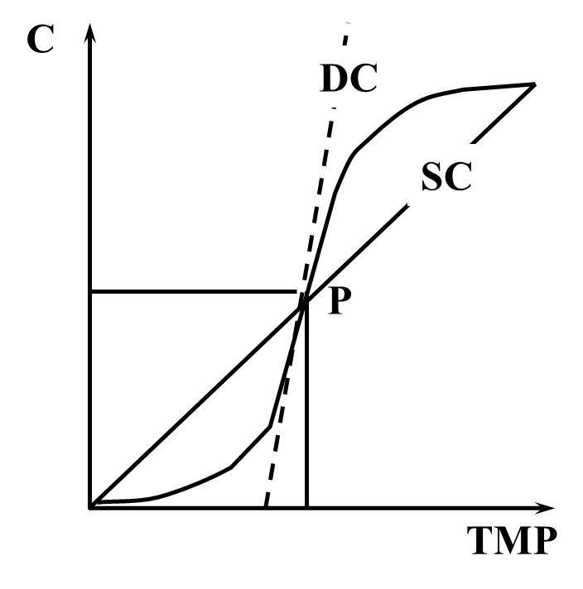

Wall components and Compliance:

Passive components: Conjonctive/elastine

Active acive components : Muscular media (Reflex vaso constriction/relaxation)

2- Visco-elasticity.

Calibre = Tension/ Visco-elasticity

Visco-elasticity ( delayed elasticity) is another vascular feature particularly related to the veins which accounts for:

1-the delayed caliber response C to the TMP ( Fluage F ) that interfere with the Dynamic compliance.

2- the lower TMP capable to maintain Q ( Relaxation R) than which was necessary to achieve it that interferes with the hysteresis phenomenon.

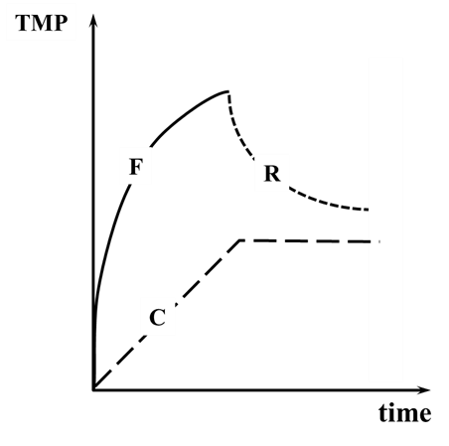

3- Reservoir effect

Compliance and viscolelasticity vary according to the wall veins components. The high compliance of the venous bed is responsible for the capacitive effect called “reservoir effect” that allows a great variation of volume with a small variation of pressure, so providing a variable flow according to the right heart necessity without a substantial venous pressure change.

4- Wall remodeling

The more the radius, higher the tension for the same TMP. The physiological response is the media thickening according to the Starling law…which reinforces the wall and reduces the compliance. This is a biologic response that limits the venous dilation attested by the wall thickening of the GSV when overloaded/strained by SFJ reflux.

The hysteresis, i.e the Caliber/volume reduction secondary to a TMP decrease, depends of the wall structure that consists in wall remodeling that can take long time (weeks) after refluxing SFJ disconnection.

ANLIKER M, YATES WG, OGDEN E (1971) Transmission of small pressure waves in the canine vena cava. Am J Physiol 221: 644-51.

BIA D, ARMENTANO R, CRAIEM D, GRIGNOLA J, GINES F, SIMÓN A, LEVENSON J (2004) Smooth muscle role on pulmonary arterial function during acute pulmonary hypertension in sheep. Acta Physiol Scand 181: 359-66.

BRADLEY JG, DAVIS KA (2003) Orthostatic hypotension. Am Fam Physician 68: 2393-8.

FRANCESCHI C, ZAMBONI P. Principles of venous haemodynamics. Novapublishers. New York. 2010

FREEMAN R, LIROFONIS V, FARQUHAR WB, RISK M (2002) Limb venous compliance in patients with idiopathic orthostatic intolerance and postural tachycardia. J Appl Physiol 93: 636-44.

HOLTZ J 1996): Peripheral circulation: Fundamental concepts, comparative aspects of control in specific vascular sections, and lymph flow. GREGER R, WINDHORST U. (eds.), Comprehensive human physyiology. From cellular echanisms to integration. Berlin Heidelberg, Springer-Verlag, pp: 1865-1915.

MENDOZA E, BERGER V, ZOLLMANN C, BOMHOFF M, AMSLER F. Diameter-reduction of the great saphenous vein and common femoral vein after CHIVA. Phlebologie

MONOS E, BERCZI V, NADASY G (1995) Local control of veins: biomechanical, metabolic, and humoral aspects. Physiol Rev 75: 611-66

NIPPA JH, ALEXANDER RH, FOLSE R (1971) Pulse wave velocity in human veins. J Appl Physiol 30, 558-63.

OLSEN H, VERNERSSON E, LANNE T (2000) Cardiovascular response to acute hypovolemia in relation to age. Implications for orthostasis and hemorrhage. Am J Physiol Heart Circ Physiol 278:H222-32.

SILVER FH, SNOWHILL PB, FORAN DJ (2003) Mechanical behavior of vessel wall: a comparative study of aorta, vena cava, and carotid artery. Ann Biomed Eng 31: 793-803.

ZÓCALO Y, PESSANA F, BIA D, ARMENTANO R (2006) Regional differences in vein wall dynamics under arterial haemodynamic conditions. Artif Organs 30: 265-75.