Fluid mechanics, Venous hemodynamics and EBM.
Claude Franceschi
A hemodynamic model of the venous system is proposed in order to link the various clinical and instrumental data of the hemodynamic aspect of the venous disease in a coherent cause/effect system. As any model, it doesn’t pretend to be the final truth, but an “all goes as if” improvement.
Introduction
According to the scientific community,
1-Evidence can be produced by 2 processes:
a- Evidence where facts or observations support an assertion e.g EBM. It relies mostly on literature reporting clinical diagnosis signs/symptoms and treatment outcomes statistically proved, represented by studies, trials and RCT, independently of the model e.g hemodynamic.
b- Evidence given by demonstration: a formal series of statements showing that if one thing is true something else necessarily follows from it. It provides a rational statement of a concept ( hemodynamic concepts).
2- Induction scientific process provides a theory based on facts, observation and rational/scientific demonstration. A scientist observes something, forms a hypothesis, and performs some experiments to verify the hypothesis, then, when all is said and done, creates a theory. Indeed, this seems like the most pure way to perform science. Obviously, any new theory even if better than the previous ones, it is never the final truth, but a step intended for further improvement/changes.
3-Validation is an official sanction, confirmation, or approval to scientific study relevance. It is supposed to be given by one or more experts in all the issues included in the study. Its refusal should be explicated in detailed scientific reasoning e.g fluid mechanics, instrumental techniques and their implementation, etc…
2/Venous Hemodynamics evidence based on facts and observations
Facts and observations related to the venous circulation must be distinguished from those witch relate to other patho-physiologic causes. Therefore, they can be asserted only when produced by hemodynamic changes.
On the one hand, CHIVA as a treatment is evaluated according to EBM. The criteria were clinical and instrumental. 3 RCT CHIVA vs stripping give homogeneous results and show better long term outcomes (5,10 years) in terms of varicose recurrence. A fourth RCT vs compression, has demonstrated better CHIVA results in terms of venous ulcer recurrence.
On the other hand, these EBM results give worth to the hemodynamic pattern that led the strategy. The latter was elaborated from clinical and instrumental data in order to gather them in a coherent system.

A: Fluid Mechanics and Venous Hemodynamics CHIVA Patterns
B: EBM and CHIVA Outcomes
C: Cochrane Review Protocol
Chronic venous insufficiency due to valve incompetence
A/ Fluid Mechanics and Venous Hemodynamics CHIVA Patterns
1- Gravitational hydrostatic Pressure (GHP) Fractioning impairment
Is concept of Gravitational hydrostatic Pressure (GHP) Fractioning impairment scientifically consistent in venous disease affected by valve incompetence ?
a-Clinical data:
-Varicose veins caliber:
- maximum in upright position , varicose caliber collapses in proportion to the foot elevation above the heart.
- Trendelenburg maneuver ( 1891): compression of the varicose GSV with a finger in lying position when collapsed by this position, then asking the patient to stand up while keeping the compression, shows a delayed swelling compared to the same action without compression.
Trendelenburg operation: Substituting the finger compression by a GSV ligation led to underlying GSV collapse and ulcer healing.
CHIVA: varicose veins collapse after proximal varicose veins disconnection [1,2,3].
- Skin drainage impairment: Edema, skin disorders and ulcers reduce/heal with prolonged lying stance and increases in upright position. Most cured by Trendelenburg’s operation and CHIVA[4].
b-Instrumental data :
Invasive pressure measurement. Since half a century, , Invasive pressure measurements show pressure at the ankle around 20 mmHg in lying position and 90 mmHg in upright still stance in accordance with the GHP increase due to the blood column height variation .
“Surprisingly” the pressure at the ankle drops down to 30 mmHg when walking, whereas the upright stance[5,6].. What happened ?. Necessarily a column fractionation which leads to a GHP drop .On the other hand, this fractionation is impaired in proportion to the venous valves incompetence…..and is restored by valve incompetence repair. Thus, valves play a fractionating role only during walking, i.e when the muscles squeeze the veins and acts as a pump. This is the evidence of a dynamic column fractioning and a consequent GHP change due to the valvo-muscular pump.
Noninvasive data: Duplex US: GSV caliber reduction (thus pressure) after refluxing SFJ disconnection [7].
Conclusion: The low Ankle venous pressure in incumbent position increases in standing still normal individuals proportionally to the height of the venous blood column [“height of the venous blood column above it”]. It decreases dramatically when walking. To do that, a column fractioning is mandatory. As the ankle pressure variation is similar in both normal and valve incompetence except when walking where the latter doesn’t show a substantial decrease, the competent valves are necessary for fractioning. Besides, the valve competence doesn’t fractionate the column at rest but only when walking, i.e actioning the leg muscles. So, muscular action and competent valves are the necessary conditions for a correct fractioning. Therefore muscle + valves work (like an alternate pump valvo-muscular pump (VMP)) that fraction dynamically the column, resulting in Dynamic Fractioning of the Gravitational Hydrostatic Pressure (DFHP). So, restoring DFHP in venous incompetence needs a valve repair/graft/prosthetic valve) or venous staggered stops (CHIVA). QED. QED quod erat demonstrandum Quod erat demonstrandum (Latin ''what had to be proved'' or ''what was to be demonstrated

2- TMP and Residual pressure RP
Is trans-mural pressure the final parameter for tissue drainage and veins caliber?
21- Residual pressure RP
RP is a classical academic parameter of the venous system. It is the part of the venous pressure provided by the artery though the microcirculation. Its value is much lower than the arterial ( around 20 mmHg) due to the pressure fall in the microcirculation resistance. So it varies with the microcirculation resistance regulation/vasoregulation
22- Trans-mural pressure TMP is the pressure difference between TMP the capillary and venous bed ( GHP,RP and VMP pressure) and the extra-venous pressure (tissues, atmospheric pressure) . Besides the Starling law regarding the micro-circulation that states TMP as central in the drainage function of the venous end of the capillaries, clinical and instrumental data demonstrate its central relevance in venous disease.
Clinical data:
Edema, skin disorders and ulcer are relieved/cured by compression i.e increasing the extravenous pressure or endo-venous pressure reduction ( recumbent , DFHP restore)

,
3- Venous Shunts
Venous shunts are defined as veins through which blood is diverted from its normal path. (Shunt: Dictionary definition. Verb: to shove or turn (someone or something) aside or out of the way. Noun: channel through which blood or other bodily fluids diverted from its normal path. http://dictionary.reference.com/browse/shunt?s=ts)
Different venous shunt patterns can be described according to their topography, the origin and destination of their abnormal flow added to their normal outflow (physiological draining flow).
Do Closed shunts (CS) , Open deviated shunts (ODS) and Open Vicarious shunts (OVS) match the fluid mechanics patterns and clinical/instrumental venous assessment ?
Deviate Dictionary :: turn aside; be at variance with; cause to turn away from a previous or expected course; markedly different from an accepted norm; a person whose behavior deviates from what is acceptable especially in sexual behavior
http://www.kgbanswers.com/whats-the-definition-o
Vicarious: Experienced or gained by the loss or to the consequence of another, such as through watching or reading. Done on behalf of others
31-Closed shunts CS: Physical conditions and behavior vs venous CS:
311-Material Condition
3111- Material system Physical Condition a conduit (a) connects to the input (e) through the connection ( b) and the output (f) through the connection (c) of an alternate pump (d) ( like heart: active variation of volume of a container placed between at least 2 valves (e and f) insuring a one way flow direction).2 additional valves located in (c) and (b) , (c) downstream to d and (b) upstream. In addition, the conduits are collapsible, flexible and compliant.
3112-Material Venous condition: Let’s take the GSV example. Anatomy shows a compliant venous conduit , connecting to the deep venous veins on each side ( e and f) of the calf valvo-muscular pump (d) , downstream above the knee through the sapheno-femoral junction SFJ (c) and upstream below the knee through one or more perforators (b). Therefore, anatomy fulfills the corresponding physical conditions. QED.
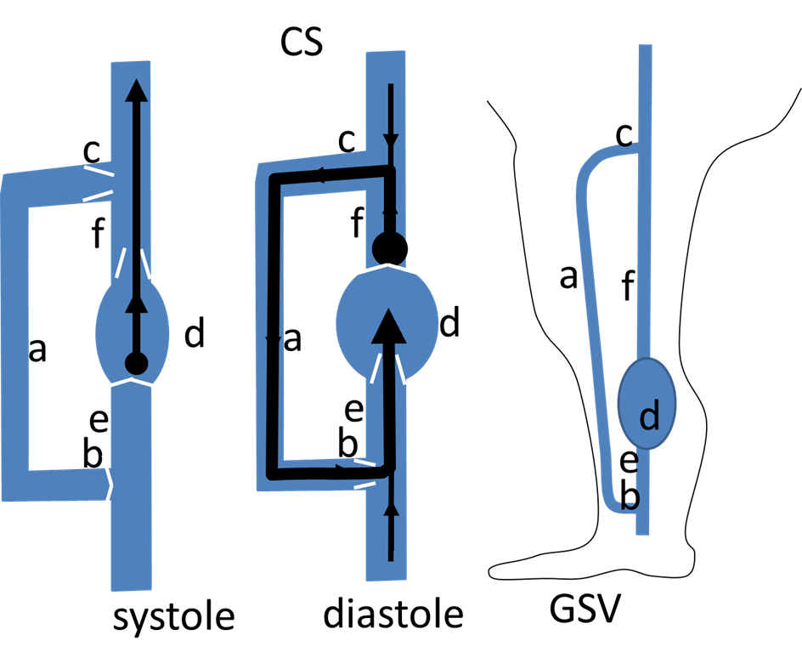
312- Physical system Behavior:
The conduits are vertical. So, the Gravitational Hydrostatic pressure GHP ( high liquid column) has to be added to the pump pressure.
As the conduits are compliant, they will change caliber according the trans-mural pressure and their Hooke’s modulus
3121- Pump contraction ( systole) produces a bidirectional Pressure Gradient (PG) d>e and d>f. If all the valves (c,f,e,b) are competent, contraction propels the flow in an antegrade unique direction d>f because d>e closes the input valve (e ) and contemporarily opens the output valve (f). This contraction produces a negligible effect on (a) flow. The (c) valve suppression doesn’t change significantly this behavior.
3122- Pump dilation (diastole) reverses GP, e>d and f>d. If all the valves (c,f,e,b) are competent, f>d closes at the same time the output valve (f) and the (c) valve while e>d opens the input valve (e ) opens aspirating (e ) .At the same time , (c ) and (f) valves closure fractionates the blood column and reduce the GHP. If the (c ) valve is absent or incompetent , e>d aspires back to (d) the (f) flow ( reflux) into (d) through (c ), (a) then (b).This produces a “closed circuit” where a “closed shunt” (CS) is triggered by the (d) diastole. This CS is loaded with pressure provided by the (d) and so, the (e ) diastolic pressure decreases less than before This phenomenon is amplified in these vertical conduits, because of the GHP column is no more fractionated by the (c ) valve closure during the diastole. (c) valve restore or disconnection, restores the normal pressures. If (d) functioning is impaired by (e) and (f) valves absence/incompetence, diastole doesn’t any more reduce (e ) and (d) pressure and hampers the (b) inflow such as reducing/ablating the (f) and (a ) reflux (f,d,e competitive reflux).
313- Venous system behavior:
Let’s keep the GSV example.
3131- Pressure changes. If all the valves (c,b,e,f) are competent, invasive pressure measurement show that, during the Valvo-muscular action of the calf (walking) , the pressure difference PD is high in normal patients (50>30 mmHg) thanks to the pressure decrease below the knee (ankle). On the contrary, when a closed shunt is formed, i.e SFJ valve (c ) and its trunk (a ) are incompetent, the ankle pressure decrease is impaired. ( >30 mmHg up to 90 at the ankle according to the incompetence grade) despite the deep proper valves of the pump are competent. (5,6). (c ) disconnection fractionating the GHP column and disconnecting the CS leads to a GSV caliber decrease (7). So this effect is in accordance with the CS physical experiment regarding the pressure changes. Clinical data as Perthes test show that a tourniquet blocking at the proximal incompetent GSV (a) make the caliber collapse ( pressure drop) of the veins below the tourniquet when walking if the calf pump functioning is correct http://www.youtube.com/watch?v=okGQM9vZuwY&feature=plcp, http://www.dailymotion.com/video/x5q55p_chiva-shunt-i-et-ii_tech?search_algo=1
. This collapse is impaired proportionally to the pump efficacy ( e.g pump proper valves incompetence) because of the PG reduction (labeled “competitive deep reflux” http://www.youtube.com/watch?v=uginWNM5Bj4&feature=plcp) QED.
3132- Flow changes.
When the SFJ (c) called escape point and GSV trunk ( a) valves are incompetent, a diastolic reflux ( calf squeezing and Paranà relaxation phase) fed by the common femoral vein (f) is recorded down to a one or more below knee perforators (b) where it re-enters in the deep veins (e ). (8) These perforators are labeled “re-entries”. This flow assessed by daily Duplex US exanimations and recorded by all the sonographers (9) http://www.youtube.com/watch?v=JFQzsf0fFLI .This flow behavior is in accordance with the CS physical model. CS can be formed by any escape point, shunting vein and re-entry. QED.
32- Open Deviated Shunts ODS: Physical conditions and behavior vs venous ODS:
Deviate Dictionary: turn aside; be at variance with; cause to turn away from a previous or expected course
321-Material Condition
3211- Material system Physical Condition: a conduit (a) connects to the input (e) through the connection ( b) and the output (f) through the connection (c) of an alternate pump (d) ( like heart: active variation of volume of a container placed between at least 2 valves (e and f) insuring a one way flow direction).2 additional valves located in (c) and (b) , (c) downstream to d and (b) upstream (Fig 1A). Two more conduits (g) and (h) are connected. (g) to (a) and (h) to (a) and (e ) through a connection (i). (a), (b), (g) and (h) an additional pump (j) imposes a pressure difference on either side of a variable resistance(r ). . In addition, the conduits are collapsible, flexible and compliant.
3212-Material Venous condition: Let’s take the GSV example. Anatomy shows a venous conduit ( GSV trunk (a ) , connecting to the deep venous veins on each side ( e and f) of the calf valvo-muscular pump (d) , downstream above the knee through the sapheno-femoral junction SFJ (c) and upstream below the knee through one or more perforators (b). In addition, many tributaries connect to (a) and among them, a tributary (g) and an other that connects also to (e ) through (i). the arterial system imposes a pressure and feeds all veins with a blood flow through the micro-circulation resistances . Therefore, anatomy fulfills the corresponding physical conditions. QED.
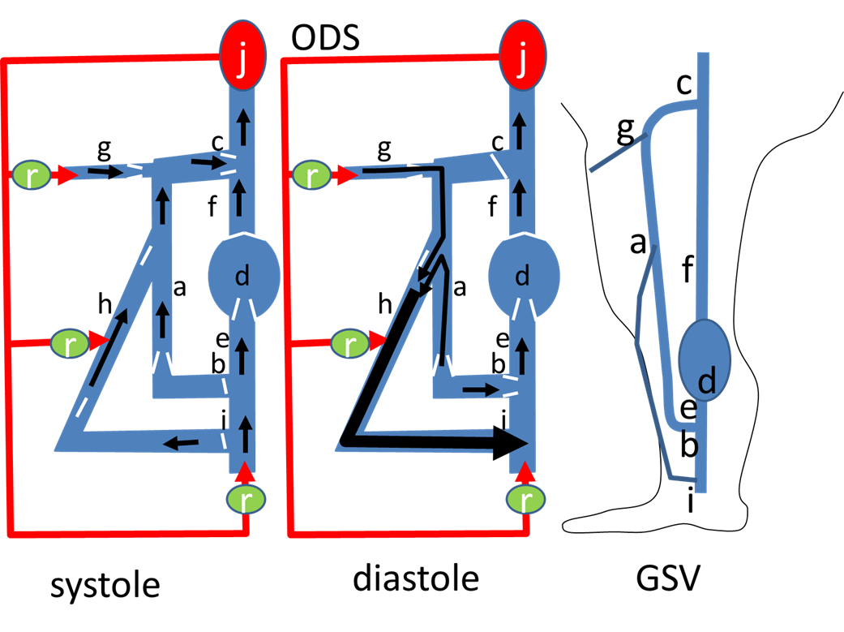
322- Physical system Behavior:
Being collapsible, flexible and compliant, the pressure variation will change the caliber in proportion to the pressure and depending on the Hooke’s modulus of the conduit material. The conduits are vertical. So, the Gravitational Hydrostatic pressure GHP ( high liquid column) has to be added to the pumps ( d and J) pressure.
3221- The conduits are vertical. Pump contraction ( systole) produces a bidirectional Pressure Gradient (PG) d>e and d>f. If all the valves (c,f,e,b,h,g,i)) are competent, contraction propels the flow in an antegrade unique direction d>f because d>e closes the input valve (e ) and contemporarily opens the output valve (f). This contraction produces a negligible effect on (a) flow. The (c) valve suppression doesn’t change significantly this behavior.
3222- Pump dilation (diastole) reverses GP, e>d and f>d. If all the valves (c,f,e,b,h) are competent, f>e PG closes at the same time the output valve (f, c,a,h,c) valve while the input valve (e ) opens aspirating (e ) .At the same time , (f,c,h,a,) valves closure fractionate the GHP column.
If the (h) valves are absent or incompetent , e>d aspires back to (g, upper (a) and (h) flow ( reflux) into (d) through ( upper a ) and (h).This produces an Open deviate Shunt ODS , in open circuit ( because no return in closed through (c ) which is competent. In addition to the its small flow fed by (j), it is overloaded by (g) and (a). This deviation is due to a diastolic PG (g>i>e) preferential to g>c>f that can produce a reflux thanks to (h) incompetence and the absence of valve between (g) and the upper (a). This phenomenon is amplified in these vertical conduits, because of the GHP column is no more fractionated between (c), and (i). Upper (h) valve restore or disconnection, disconnects the overloading flow and at the same time fractionates the GHP despite a diastolic reflux remains, but with a lower pressure contribution.
323- Venous system behavior:
Let’s keep the GSV example.
3231- Pressure changes. If all the valves (c,b,e,f) are competent, invasive pressure measurement show that, during the Valvo-muscular action of the calf (walking) , the PG [come prima sarebbe meglio mettere “PD”=pressure difference, ma non è fondamentale] is high in normal patients (50>30 mmHg) thanks to the pressure decrease below the knee (ankle). On the contrary, when a ODS is formed, the(h) tributary dilates because (h) valves being incompetent, the GHP column [anche qui mettere solo “GHP”] is no more fractionated between (g,c) and (i) and it is overloaded by (g) and (a ) flow/pressure. (h) disconnection at its junction with (a), relieves the overloading flow/pressure and at the same time fractionates the GHP column [anche qui “GHP”]. Clinical data as Perthes test show that a tourniquet blocking the upper end of incompetent tributary, makes its caliber collapse ( pressure drop) when walking if the calf pump functioning is correct. So this effect is in accordance with the CS physical experiment regarding the pressure changes http://www.youtube.com/watch?v=JScby8a0zZY. QED.
3232- Flow changes.
When the (h) upper junction to (a ) labeled “escape point” is incompetent, a diastolic reflux ( calf squeezing and Paranà relaxation phase) is recorded in the overlying portion of the GSV trunk ( but not at the competent SFJ) and flows down into the incompetent tributary (h) then into deep veins upstream the calf pump ( e) through the re-entry perforator (i). This flow is assessed by daily Duplex US exanimations and recorded by all the sonographers (ref consensus). It’s behavior is in accordance with the ODS physical model. ODS can be formed by any escape point provided it doesn’t connect to the deep veins, otherwise it would be in closed circuit, thus a CS. (h) disconnection at its junction with (a), shows only a physiologic draining flow despite refluxing (10). QED.

33- Open Vicarious Shunts OVS: Physical conditions and behavior vs venous ODS:
Dictionary: Vicarious: Experienced or gained by the loss or to the consequence of another

Open Vicarious Shunts (OVS) are veins that by-pass any obstructed vein in order to allow the drainage. Their physical/physiological rational is undisputable and agreed by the medical community. We just remember that a venous obstruction leads to upstream drainage impairment and pressure excess that are relieved by any by-pass, provided the latter is appropriate http://www.youtube.com/watch?v=6laB-3KfsD8&feature=autoshare . CHIVA is conservative, in order not only to preserve potential grafts , but also for physiologic reasons: avoid skin disorders due to drainage impairment and prevent varicose recurrence due to OVS effect .QED.
B/ EBM and CHIVA Outcomes
4 RCTs demonstrate the efficacy of CHIVA long term results 3 vs Stripping regarding varicoses veins (1,2,3), and 1 vs compression regarding venous ulcer (4)
References Paragraph A and B
- Carandina S, Mari C, De Palma M, Marcellino MG,Cisno C, Legnaro A, et al.Varicose Vein Stripping vsHaemodynamic Correction (CHIVA): a long term randomised trial. European Journal of Vascular and Endovascular Surgery 2008;35(2):230–7
- Parés JO, Juan J, Tellez R, Mata A, Moreno C, Quer FX,et l.Varicose vein surgery: stripping versus the CHIVA Method: a randomized controlled trial. Annals of Surgery 2010;251(4):624–31
- Iborra-Ortega E, Barjau-Urrea E, Vila-Coll R, Ballon-Carazas H, Cairols-Castellote MA. Comparative study oftwo surgical techniques in the treatment of varicose veins of the lower extremities: results after five years of followup
- [Estudio comparativo de dos técnicas quirúrgicas en el tratamiento de las varices de las extremidades inferiores: resultados tras cinco años de seguimiento]. Angiología 2006; 58(6):459–68. P.Zamboni and all: Minimally Invasive Surgical management of primary venous Ulcer vs. Compression Eur J vasc Endovasc Surg 00,1 6 (2003)
- Bjordal R. “Simultaneous pressure and flow recordings in varicose veins of the lower extremity” Acta Chir Scand 1970; 136:309-317
- Recek C, Pojer H. Ambulatory pressure gradient in the veins of the lower extremity. VASA 2000; 29:187-90
- Mendoza E, Berger V, Zollmann C, Bomhoff M, Amsler F. Diameter-reduction of the great saphenous vein and common femoral vein after CHIVA. Phlebologie
- Cappelli M, Molino Lova R, Ermini SZamboniP . Hemodynamics of the saphenous-femoral junction. Patterns of reflux and their clinical implications. International Angiology vol 23 March 2004 N°1 pag. 25 – 28 )
- Nicolaides AN, The International Consensus Group“ The investigation of chronic venous insufficiency. A Consensus Statement”. Circulation 2000, 102 (20):e126
- P. Zamboni*, S. Gianesini, E. Menegatti, G. Tacconi, A. Palazzo, A. Liboni “Great saphenous varicose vein surgery without saphenofemoral junction disconnection” British Journal of Surgery Volume 97, Issue 6, pages 820–825, June 2010
Additional references to Paragraph A and B

1. Pollack AA, Wood EH. Venous pressure in the saphenous vein at the ankle in men during exercise and change in position. J Appl Physiol 1949;1:649-62.
2. Meissner MH, Moneta G, Burnand K, Gloviczki P, Lohr JM, Lurie F et al. The hemodynamics and diagnosis of venous disease. J Vasc Surg 2007 Dec; 46 Suppl S:4S-24S.
5. Kügler C, Strunk M, Rudofsky G. Venous pressure dynamics of the healthy human leg. Role of muscle activity, joint mobility and anthropometric factors. J Vasc Res. 2001 Jan-Feb;38(1):20-9.
6. Hosoi Y, Zukowski A, Kakkos SK, Nicolaides AN. Ambulatory venous pressure measurements: new parameters derived from a mathematic hemodynamic model. J Vasc Surg 2002;36:137-42.
7. Welkie JF, Comerota AJ, Katz ML, Aldridge SC, Kerr RP, White JV. Hemodynamic deterioration in chronic venous disease. J Vasc Surg. 1992 Nov;16(5):733-40.
8. Partsch B, Mayer W, Partsch H. Improvement of ambulatory venous hypertension by narrowing of the femoral vein in congenital absence of venous valves. Phlebology 1992; 7: 101-104

.
C/ Cochrane Review Protocol : CHIVA method for the treatment of varicose veins (Protocol) 3
Copyright © 2012 The Cochrane Collaboration. Published by JohnWiley & Sons, Ltd.
Venous insufficiency is the inability to drive venous blood flow to the heart in response to tissue drainage, thermoregulation, and hemodynamic reserve. Venous insufficiency may entail all the factors involved in venous return, the venous wall and valve system,posture, the muscle pump, and respiratory and venule-capillary bed factors. When referring to the syndrome of chronic venous insufficiency (CVI), all signs and symptoms characteristic of this
disease of the lower limbs must be addressed. Subjectively, patients report pain, fatigue, heaviness, warmth, swelling, etc., which are more intense when standing and under environmental conditions of heat and humidity (Vanhouette 1997). Objectively, varicose veins, reticular veins, edema, skin changes, and healed or active ulcers, or both, are found. CVI is a chronic disease of multicausal origin with a slow evolution of symptoms. CVI complications (ulcers, phlebitis, superficial or deep vein thrombosis, skin complications) often appear years or even decades after the onset of symptoms (Kurz 1999). The prevalence of CVI in the general population depends on the outcome considered. It has been estimated that the prevalence of trunk varices ranges from 30% to 40% in the general population (Lee
2003) and that 15% of females and 9% of males have reflux conned to the super cial venous system (Allan 2000). According to Carpentier 2004, varicose veins of any type can be detected in up to 50% of women in the general population.
The introduction of duplex scanning in the study of CVI has allowed in vivo knowledge of venous hemodynamics (Franceschi1997). In addition to allowing the completion of a morphological study, this exploration facilitates themapping of the hemodynamics of the venous system, providing precise information on any changes or abnormalities (Cavezzi 2007; Coleridge-Smith 2006; Labropoulos 2005; Lambropoulos 2001; Nicolaides 2000).
Treatment of CVI depends on the state of development of the disease (Agus 2001). There are several therapeutic options that can be used in combination to treat this disease. These therapies cannot cure the disease but can improve symptoms and prevent complications.
Treatments for CVI include hygiene and postural measures such as elevation of the legs or walking around to keep the muscle pump working, compression therapy (Nelson 2000;Nelson 2011; O’Meara 2009), topical treatment (Aziz 2011; Cullum 2010; Jull 2008; Kranke 2004;O’Meara 2010; Palfreyman 2006), drug therapy (Martinez-Zapata 2005; O’Meara 2010), sclerotherapy (Tisi2006), laser therapy (Flemming 1999), radiofrequency ablation
(Nesbitt 2011) and surgery (Rigby 2004).
During the 20th century, the first major step in the treatment of varicose veins of the lower limbs was removing the saphenous vein through a metal loop, designed by Keller in 1905. In May 1906, Keller also described the technique of endoluminal stripping. Two years later Babcock first used a flebo-extractor similar to that used today (Lofgren 1977). In 1966, Muller’s ambulatory phlebectomy was described (Muller 1966).However, based on the available literature, treatment that involves these techniques cannot prevent varicosity recurrence (Blomgren 2004; Perrin 2000;
Winterborn 2004). Besides the possibility of surgical errors, this treatment does not allow for the prevention of the development of new varicose veins (Labropoulos 2005) or the remodeling of the venous network of subcutaneous tissue (Juan 2002). Surgery that removes saphenous veins is generally associated with the presence
of varicosities or telangiectasias, and sometimes leads to a clinical cosmetic outcome that is poorer than before surgery. These inconveniences are difficult to justify in patients with clinical grade C2 of the Clinical picture, Etiology, Anatomic distribution and Pathophysiology (CEAP) classification (Porter 1995) (Table 1).
Description of the intervention
In 1988, Franceschi (Franceschi 1988) described a procedure for the treatment of CVI based on hemodynamic performance of the elements that determine the emergence of varicose veins with preservation of the superficial venous system. Francheschi called this procedure the Conservative Hemodynamics of Ambulatory
Venous Insufficiency (CHIVA) cure. Although normally applied via surgery, CHIVA is not a technique but a strategy that can be delivered via surgery, sclerosis, laser or endovascular procedures. The CHIVA method is based on the modification of the hemodynamics of the venous system to eliminate
varicose dilatations. This theory is supported by the findings of Mendoza and Escribano (Escribano 2003; Mendoza 2011). The authors demonstrate that CHIVA produces a regression of the diameter size of the saphenous vein (1.6 to 2.6mm) and the femoral vein (0.4 to 0.7 mm) involved in the venous shunt (Escribano 2003; Mendoza 2011).
How the intervention might work
Primary varicose veins are hemodynamically characterized by the existence of a retrograde circuit or venous-venous shunt (Goren 1996). This circuit consists of a retrograde proximal reflux point (escape point) from which blood from the deep venous system is discharged into the superficial venous system, usually the saphenous veins. The hydrostatic pressure column, between the escape point and the point of re-entry into the deep venous system, generally comprises the saphenous vein and the perforating vein reentry. This point of venous retrograde re-entry circuit drains back into the deep venous system. The CHIVA method is a minimally invasive surgery procedure,
usually performed under local anesthesia, based on the findings of a careful analysis of the hemodynamic superficial venous network by echo-doppler.
The principles underlying the CHIVA method are:
1. fragmentation of the venous pressure column;
CHIVA method for the treatment of varicose veins (Protocol) 2
Copyright © 2012 The Cochrane Collaboration. Published by JohnWiley & Sons, Ltd.
2. disconnecting the venous-venous shunts;
3. preservation of the perforators re-entry;
4. abolition of undrained superficial varicose veins.
The aim of the CHIVA treatment is to decrease the hydrostatic column pressure to disrupt venous-venous shunts without removing the saphenous vein and the venous drainage of the superficial tissues of the limb.
Why it is important to do this review
There are some clinical trials that provide evidence about the efficacy of the CHIVA strategy compared with stripping (the gold standard treatment) (Carandina 2008; Iborra 2006; Pares 2010).
CHIVA is one of the few strategies that treat varicose veins without seeking their destruction.
O B J E C T I V E S
To evaluate the efficacy and safety of the CHIVA technique compared with other procedures to treat varicose veins.
M E T H O D S
Criteria for considering studies for this review
Types of studies
Randomized controlled trials (RCTs).
Types of participants
Males and females over 18 years of age suffering from CVI, CEAP stage from 2 to 6.
Types of interventions
RCTs that assess the technique of CHIVA compared with other procedures to treat varicose veins, such as drugs, compressive measures, laser therapy, radiofrequency, stripping, sclerotherapy or any other.
Types of outcome measures
Primary outcomes
Recurrence of varicosity, defined as the appearance of new varicose veins after a minimum length of follow-up of one year.
Secondary outcomes
Re-treatment, defined as patients’ need for a new intervention due to persistent varicose veins or new varicose veins in the same leg and the same area.
Clinic or aesthetic changes after a minimum length of follow-up of one month after the intervention as assessed by the following.
• Objective signs:
◦ free from reflux, checked by echo-doppler;
◦ edema measured by the dichotomous variable ’edema’ and the continuous variables ’ankle perimeter ircumference’ and ’volume of the leg’;
◦ skin manifestations such as venous ulcers and trophic alterations, which may include telangiectasia (small red points on the skin caused by permanently opened tiny blood vessels), reticular veins (dilated veins which show as a net-like pattern on the skin), varicose veins (permanently dilated veins), or lipodermatosclerosis (a hardening of the skin which may gain a red or brown pigmentation and is accompanied by wasting of the subcutaneous fat).
• Subjective symptoms:
◦ pain;
◦ cramps;
◦ restless legs;
◦ itching;
◦ feeling of heaviness in the legs;
◦ swelling;
◦ paresthesias (abnormal sensations, such as prickling,
burning, tingling).
• Global assessment measures:
◦ disease-specific quality of life (QoL) scales (e.g. CVIIQ or Veines-qol) or satisfaction of participants, or both.
Side effects
• participants who experience adverse events during the trial, as reported by questionnaire or related by the participants and specified within the publication, such as hematoma, infection, superficial or deep venous thrombosis, lung embolism, nerve injury.
Search methods for identification of studies
Electronic searches
The Cochrane Peripheral Vascular Diseases Group Trials Search Co-ordinator (TSC) will search the Specialised Register and the Cochrane Central Register of Controlled Trials (CENTRAL), part of The Cochrane Library, www.thecochranelibrary.com. See Appendix 1 for details of the search strategy which will be used to
search CENTRAL. The Specialised Register is maintained by the
CHIVA method for the treatment of varicose veins (Protocol) 3
Copyright © 2012 The Cochrane Collaboration. Published by JohnWiley & Sons, Ltd.
Additional references
Agus 2001
Agus GB, Allegra C, Arpaia G, Botta G, Cataldi A, Gasbarro V, et al.Guidelines for the diagnosis and treatment of chronic venous insufficiency. International Angiology 2001;20(1):1–37.
Allan 2000
Allan PL, Bradbury AW, Evans CJ, Lee AJ, Vaughan Ruckley C, Fowkes FG. Patterns of reflux and severity of varicose veins in the general population – Edinburgh Vein Study. European Journal of Vascular and Endovascular Surgery 2000;20(5):470–7.
Aziz 2011
Aziz Z, Cullum N, Flemming K. Electromagnetic therapy for treating venous leg ulcers. Cochrane Database of Systematic Reviews 2011, Issue 3. [DOI: 10.1002/ 4651858.CD002933.pub4]
Blomgren 2004
Blomgren L, Johansson G, Dahlberg-AKerman A, Norén A, Brundin C, Nordström E, et al.Recurrent varicose veins: Incidence, risk factors and groin anatomy. European Journal of Vascular and Endovascular Surgery 2004;27(3):269–74.
Carandina 2008
Carandina S, Mari C, De Palma M, Marcellino MG, Cisno C, Legnaro A, et al.Varicose Vein Stripping vs Haemodynamic Correction (CHIVA): a long term randomised trial. European Journal of Vascular and Endovascular Surgery 2008;35(2):230–7.
Carpentier 2004
Carpentier PH, Maricq HR, Biro C, Ponçot-Makinen CO, Franco A. Prevalence, risk factors, and clinical patterns of chronic venous disorders of lower limbs: A populationbasedstudy in France. Journal of Vascular Surgery 2004;40 (4):650–9.
Cavezzi 2007
Cavezzi A, Labropoulos N, Partsch H, Ricci S, Caggiati A, Myers K, et al.Duplex ultrasound investigation of the veins in chronic venous disease of the lower limbs. UIP consensus document. Part II. Anatomy. Vasa 2007;36(1):62–71.
Coleridge-Smith 2006
Coleridge-Smith P, Labropoulos N, Partsch H, Myers K, Nicolaides A, Cavezzi A. Duplex ultrasound investigation of the veins in chronic venous disease of the lower limbs. UIP consensus document. Part I. Basic principles. European Journal of Vascular and Endovascular Surgery 2006 ;31(1): 83–92.
Cullum 2010
Cullum NA, Al-Kurdi D, Bell-Syer SEM. Therapeutic ultrasound for venous leg ulcers. Cochrane Database of Systematic Reviews 2010, Issue 6. [DOI: 10.1002/ 14651858.CD001180.pub3]
Escribano 2003
Escribano JM, Juan J, Bofill R, Maeso J, Rodríguez-Mori A, Matas M. Durability of reflux-elimination by a minimal invasive CHIVA procedure on patients with varicose veins.A 3-year prospective case study. European Journal of Vascular and Endovascular Surgery 2003;25(2):159–63.
Flemming 1999
Flemming K, Cullum NA. Laser therapy for venous leg ulcers. Cochrane Database of Systematic Reviews 1999, Issue 1. [DOI: 10.1002/14651858.CD001182]
Franceschi 1988
Franceschi C. [Théorie et pratique de la cure conservatrice et hémodynamique de l’insuffisance veineuse en ambulatoire]. Théorie et pratique de la cure conservatrice de l’insuffisance veineuse en ambulatoire. Precy-sous-Thil. France: Editions de l’Armançon, 1988.
Franceschi 1997
Franceschi C. Measures and interpretation of venous flow in stress tests. Manual compression and Parana manoeuver. Dynamic reflux index and Psatakis index [Mesures et interprétation des flux veineux lors des manoevres de stimulation. Compressions manuelles et manoeuvre de Paranà. Indice dynamique de reflux (IDR) et indice de Psatakis]. Journal des Maladies Vasculaires 1997;22(2):91–5.
Goren 1996
Goren G, Yellin AE. Hemodynamic principles of varicose vein therapy. Dermatologic Surgery 1996;22(7):657–62. CHIVA method for the treatment of varicose veins (Protocol) 5 Copyright © 2012 The Cochrane Collaboration. Published by JohnWiley & Sons, Ltd.
Higgins 2011
Higgins JPT, Green S, editors. Cochrane Handbook for Systematic Reviews of Interventions Version 5.1.0 [updated March 2011] The Cochrane Collaboration, 2011. Available from www.cochrane-handbook.org.
Iborra 2006
Iborra-Ortega E, Barjau-Urrea E, Vila-Coll R, Ballon- Carazas H, Cairols-Castellote MA. Comparative study of two surgical techniques in the treatment of varicose veins of the lower extremities: results after five years of followup [Estudio comparativo de dos técnicas quirúrgicas en el tratamiento de las varices de las extremidades inferiores: resultados tras cinco años de seguimiento]. Angiología 2006; 58(6):459–68.
Juan 2002
Juan J, Escribano JM, Maeso J. Hemodynamic after stripping of varicose vein [Hämodynamik des Varizenrezidivs nach Strippingoperation]. 18 Jahreskongress 2002 der Deutschen Gessellschaft für GefäBchirurgie -Gesellschaft für vaskuläre und endovaskuläre Chirurgie.Würzburg (Germany). 2002.
Jull 2008
Jull AB, Rodgers A,Walker N. Honey as a topical treatment for wounds. Cochrane Database of Systematic Reviews 2008,Issue 4. [DOI: 10.1002/14651858.CD005083.pub2]
Kranke 2004
Kranke P, Bennett MH, Debus SE, Roeckl-WiedmannI, Schnabel A. Hyperbaric oxygen therapy for chronicwounds. Cochrane Database of Systematic Reviews 2004,Issue 1. [DOI: 10.1002/14651858.CD004123.pub2]
Kurz 1999
Kurz X, Kahn SR, Abenhain L, Clement D, Norgren L,Baccaglini U, et al.Chronic venous disorders of the leg:epidemiology, outcomes, diagnosis and management.Summary of an evidence-based report of the VEINES task force. Venous Insufficiency Epidemiologic and Economic Studies. International Angiology 1999;18(2):83–102.
Labropoulos 2005
Labropoulos N, León L, Kwon S, Tassiopoulos A, González-Fajardo JA, Kang SS, Manssur MA. Study of the venous reflux progresión. Journal of Vascular Surgery 2005;41(2): 291–5.
Lambropoulos 2001
Labropoulos N, Tiongson J, Pryor L, Tassiopoulos AK, Kang SS,Mansour MA, et al.Nonsaphenous superficial vein reflux. Journal of Vascular Surgery 2001;34(5):872–7.
Lee 2003
Lee AJ, Evans CJ, Allan PL, Ruckley CV, Fowkes FG. Lifestyle factors and the risk of varicose veins: Edinburgh Vein Study. Journal of Clinical Epidemiology 2003;56(2): 171–9.
Lofgren 1977
Lofgren EP. The operative treatment of varicose veins. In:Rutherford RB editor(s). Vascular surgery. Philadelphia:WB Saunders, 1977:1169–75.
Martinez-Zapata 2005
Martinez-Zapata MJ, Bonfill Cosp X, Moreno RM, Vargas E, Capellà D. Phlebotonics for venous insufficiency.Cochrane Database of Systematic Reviews 2005, Issue 3.[DOI: 10.1002/14651858.CD003229.pub2]
Mendoza 2011
Mendoza E, Berger V, Zollmann C, Bomhoff M, AmslerF. Diameter-reduction of the great saphenous vein andcommon femoral vein after CHIVA. Phlebologie 2011;40:73-8.
Muller 1966
Muller R. Treatment of varicose veins by ambulatory phlebectomy [Traitement des varices par phlébectomie ambulatoire]. Phlebologie 1966;19(4):277–9.
Nelson 2000
Nelson EA, Bell-Syer SEM, Cullum NA, Webster J.Compression for preventing recurrence of venous ulcers.Cochrane Database of Systematic Reviews 2000, Issue 4.[DOI: 10.1002/14651858.CD002303]
Nelson 2011
Nelson EA, Mani R, Thomas K, Vowden K. Intermittent pneumatic compression for treating venous leg ulcers.Cochrane Database of Systematic Reviews 2011, Issue 2.[DOI: 10.1002/14651858.CD001899.pub3]
Nesbitt 2011
Nesbitt C, Eifell RK, Coyne P, Badri H, Bhattacharya V, Stansby G. Endovenous ablation (radiofrequency and laser) and foam sclerotherapy versus conventional surgeryfor great saphenous vein varices. Cochrane Databaseof Systematic Reviews 2011, Issue 10. [DOI: 10.1002/14651858.CD005624.pub2]
Nicolaides 2000
Nicolaides AN. Investigation of chronic venousinsufficiency. A consensus statement. Circulation 2000;102:e126–63.
O’Meara 2009
O’Meara S, Cullum NA, Nelson EA. Compression forvenous leg ulcers. Cochrane Database of Systematic Reviews2009, Issue 1. [DOI: 10.1002/14651858.CD000265.pub2]
O’Meara 2010
O’Meara S, Al-Kurdi D, Ologun Y, Ovington LG.Antibiotics and antiseptics for venous leg ulcers. CochraneDatabase of Systematic Reviews 2010, Issue 1. [DOI:10.1002/14651858.CD003557.pub3]
Palfreyman 2006
Palfreyman SSJ, Nelson EA, Lochiel R, Michaels JA.Dressings for healing venous leg ulcers. Cochrane Databaseof Systematic Reviews 2006, Issue 3. [DOI: 10.1002/14651858.CD001103.pub2]
Pares 2010
Parés JO, Juan J, Tellez R, Mata A, Moreno C, Quer FX,et al.Varicose vein surgery: stripping versus the CHIVAMethod: a randomized controlled trial. Annals of Surgery2010;251(4):624–31.CHIVA method for the treatment of varicose veins (Protocol) 6Copyright © 2012 The Cochrane Collaboration. Published by JohnWiley & Sons, Ltd.
Perrin 2000
Perrin MR, Guex JJ, Ruckley CV, de Palma RG, Royle JP,Eklof B, et al.Recurrent varices after surgery (REVAS),a consensus document. REVAS Group. CardiovascularSurgery 2000;8(4):233–45.
Porter 1995
Porter JM, Moneta GL. Reporting standards in venousdisease: an update. International Consensus Committee onChronic Venous Disease. Journal of Vascular Surgery 1995;21(4):635-45.
Rigby 2004
Rigby KA, Palfreyman SSJ, Beverley C, Michaels JA.Surgery versus sclerotherapy for the treatment of varicoseveins. Cochrane Database of Systematic Reviews 2004, Issue4. [DOI: 10.1002/14651858.CD004980]
Tisi 2006
Tisi PV, Beverley C, Rees A. Injection sclerotherapy forvaricose veins. CochraneDatabase of Systematic Reviews 2006,Issue 4. [DOI: 10.1002/14651858.CD001732.pub2]
Vanhouette 1997
Vanhouette PM, Corcaud S, de Montrion C. Venousdisease: from pathophysiology to quality of life. Angiology1997;48(7):559–67.
Winterborn 2004
Winterborn R, Foy C, Earnshaw JJ. Causes of varicose veinrecurrence: late results of a randomized controlled trialof stripping the long saphenous vein. Journal of VascularSurgery 2004;40(4):634–9.∗ Indicates the major publication for the study

